Web Admin
1.LFD
1.1Define LFD Letterhead
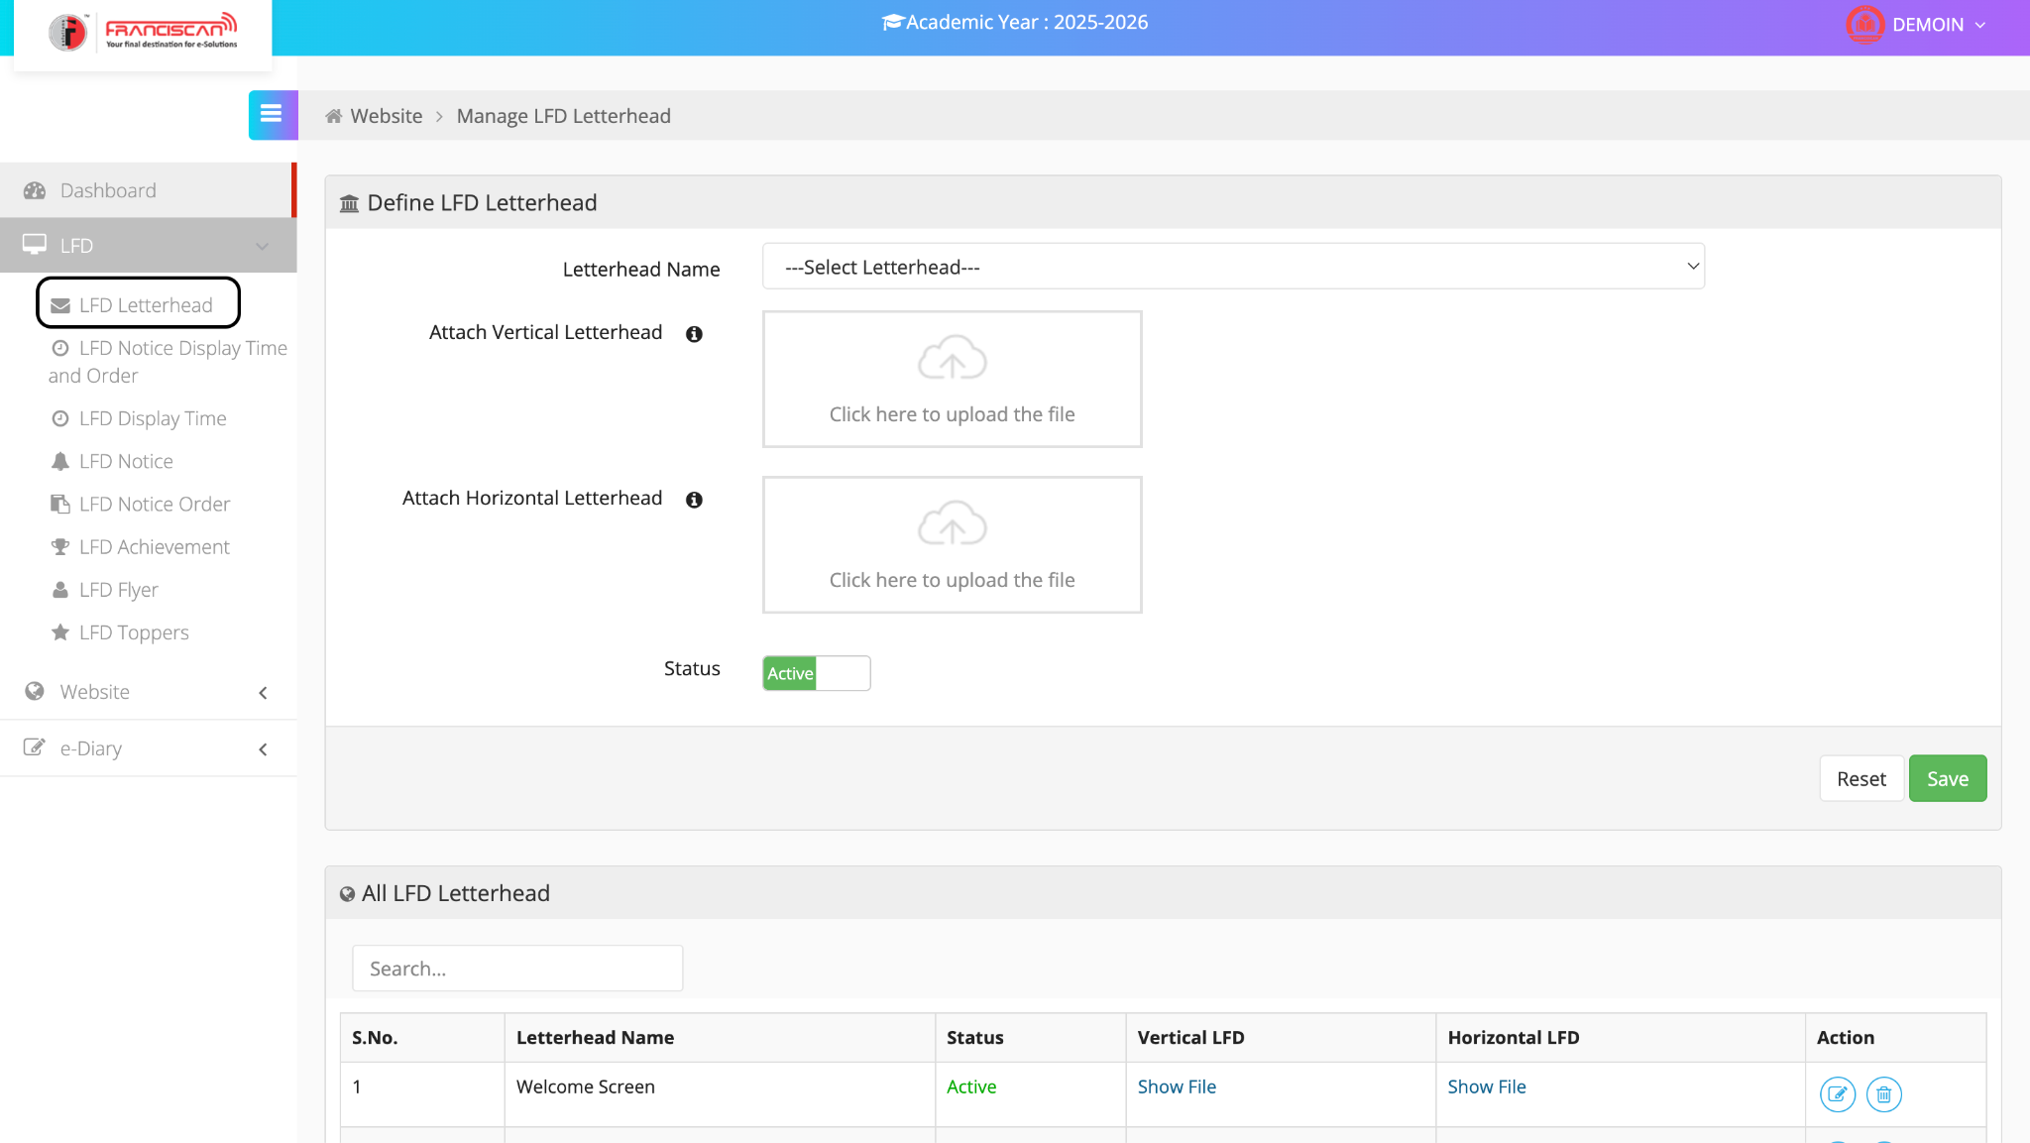

📘 ERP User Manual

Module: LFD Letterhead
Page: Manage LFD Letterhead
Academic Year: 2025–2026

🔹 Purpose:
This page is used to define and upload customized vertical and horizontal letterheads that will be displayed on the LED/LFD (Large Format Display) screens for school announcements such as notices, achievements, flyers, or welcome screens.

🔹 Navigation Path:
Dashboard > LFD > LFD Letterhead

🔹 Components of the Page:

1. Letterhead Name (Dropdown)
- Select or define the name of the letterhead.
- Example: "Welcome Screen", "Notice Header", etc.

2. Attach Vertical Letterhead
- Upload the portrait-oriented letterhead file.
- File type: Typically image formats like PNG, JPG.

3. Attach Horizontal Letterhead
- Upload the landscape-oriented letterhead file.
- Used for screens that support wider layouts.

4. Status (Active/Inactive)
- Toggle the status:
  - Active: Will be available for use.
  - Inactive: Will not be shown in display options.

5. Save Button
- Click to save the letterhead settings and uploaded files.

6. Reset Button
- Clears the current form without saving changes.

🔹 List of All LFD Letterheads (Table)
Column | Description
S.No. | Serial number of entries
Letterhead Name | Name given to the uploaded letterhead
Status | Shows if the letterhead is Active or Inactive
Vertical LFD | Link to view or download the uploaded vertical file
Horizontal LFD | Link to view or download the uploaded horizontal file
Action | Options to Edit (✏️) or Delete (🗑️) the letterhead record

✅ Steps to Add a New LFD Letterhead:
- Navigate to LFD > LFD Letterhead
- Select a Letterhead Name from the dropdown or enter a new one
- Upload both Vertical and Horizontal letterhead files
- Set the Status to "Active"
- Click Save to store the configuration
- Your letterhead will now appear in the list below for future use

💡 Tips:
- Use appropriate dimensions for vertical and horizontal files based on screen format.
- Keep letterhead designs clean and readable for display purposes.
- You can edit or delete letterheads at any time from the list below the form.

1.2Define LFD Notice Display Time & Order

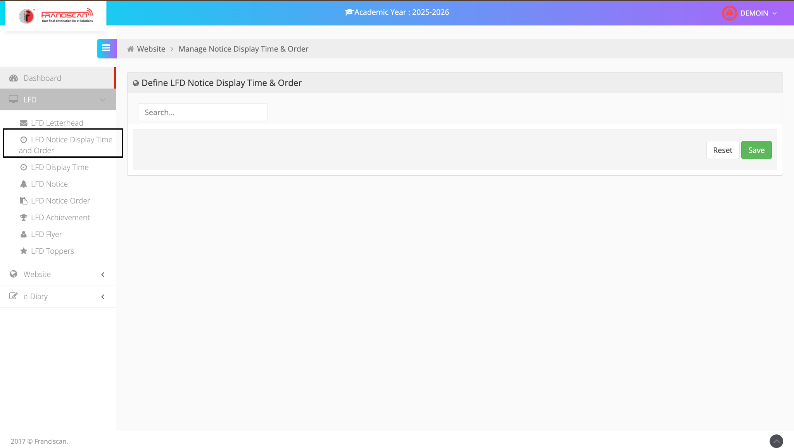

ERP Manual: LFD Notice Display Time and Order
Module: LFD
Page: LFD Notice Display Time and Order
Purpose: To define the time and sequence in which LFD notices appear on the display.

Steps to Use:
- Navigation:
  - Go to LFD from the left menu.
  - Select LFD Notice Display Time and Order.
- Define Display Settings:
  - Use the Search box to find existing notice settings.
  - Set or adjust the display time and order as required.
- Save or Reset:
  - Click Save to apply changes.
  - Click Reset to clear unsaved inputs.
1.3Define LFD Display Time & Order
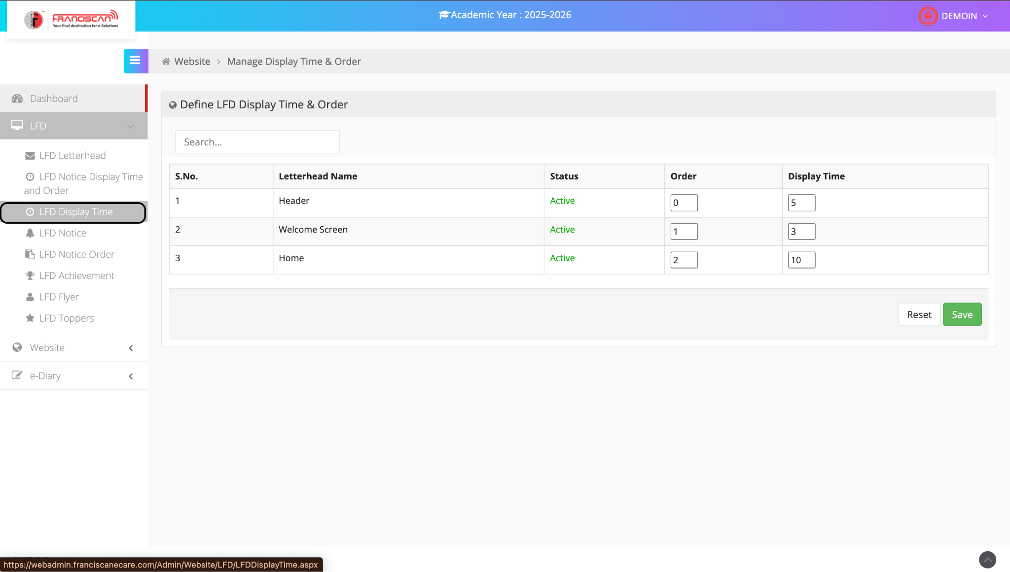

ERP Manual: LFD Display Time
Module: LFD
Page Name: Define LFD Display Time & Order
Purpose: To set the sequence and time duration for displaying different sections (letterheads) on the LFD screen.

Instructions:
- Navigation:
  - Go to LFD in the left menu.
  - Click on LFD Display Time.
- Edit Display Settings:
  - Each row represents a section: Header, Welcome Screen, Home, etc.
  - Status shows if the section is Active.
  - In the Order column, enter the sequence in which sections should appear (e.g., 0 = first).
  - In the Display Time column, enter the number of seconds each section should be shown.
- Save or Reset:
  - Click Save to apply changes.
  - Click Reset to clear unsaved inputs.

1.4Define LFD Notice
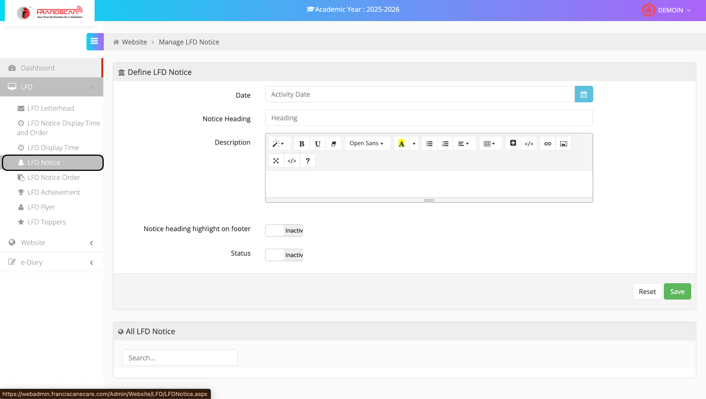ERP Manual: LFD Notice
Module: LFD
Page Name: Define LFD Notice
Purpose: To create and manage notices displayed on the Large Format Display (LFD).

Steps to Create a Notice:
- Navigation:
  - Go to LFD in the left-side menu.
  - Click on LFD Notice.
- Define Notice:
  - Date: Select the activity date using the calendar icon.
  - Notice Heading: Enter the title of the notice.
  - Description: Add detailed content using the rich text editor.
  - Notice Heading Highlight on Footer: Toggle Active if the heading should show on the LFD footer.
  - Status: Set to Active to enable the notice.
- Save or Reset:
  - Click Save to publish the notice.
  - Click Reset to clear the form.

1.5Define Notice Order
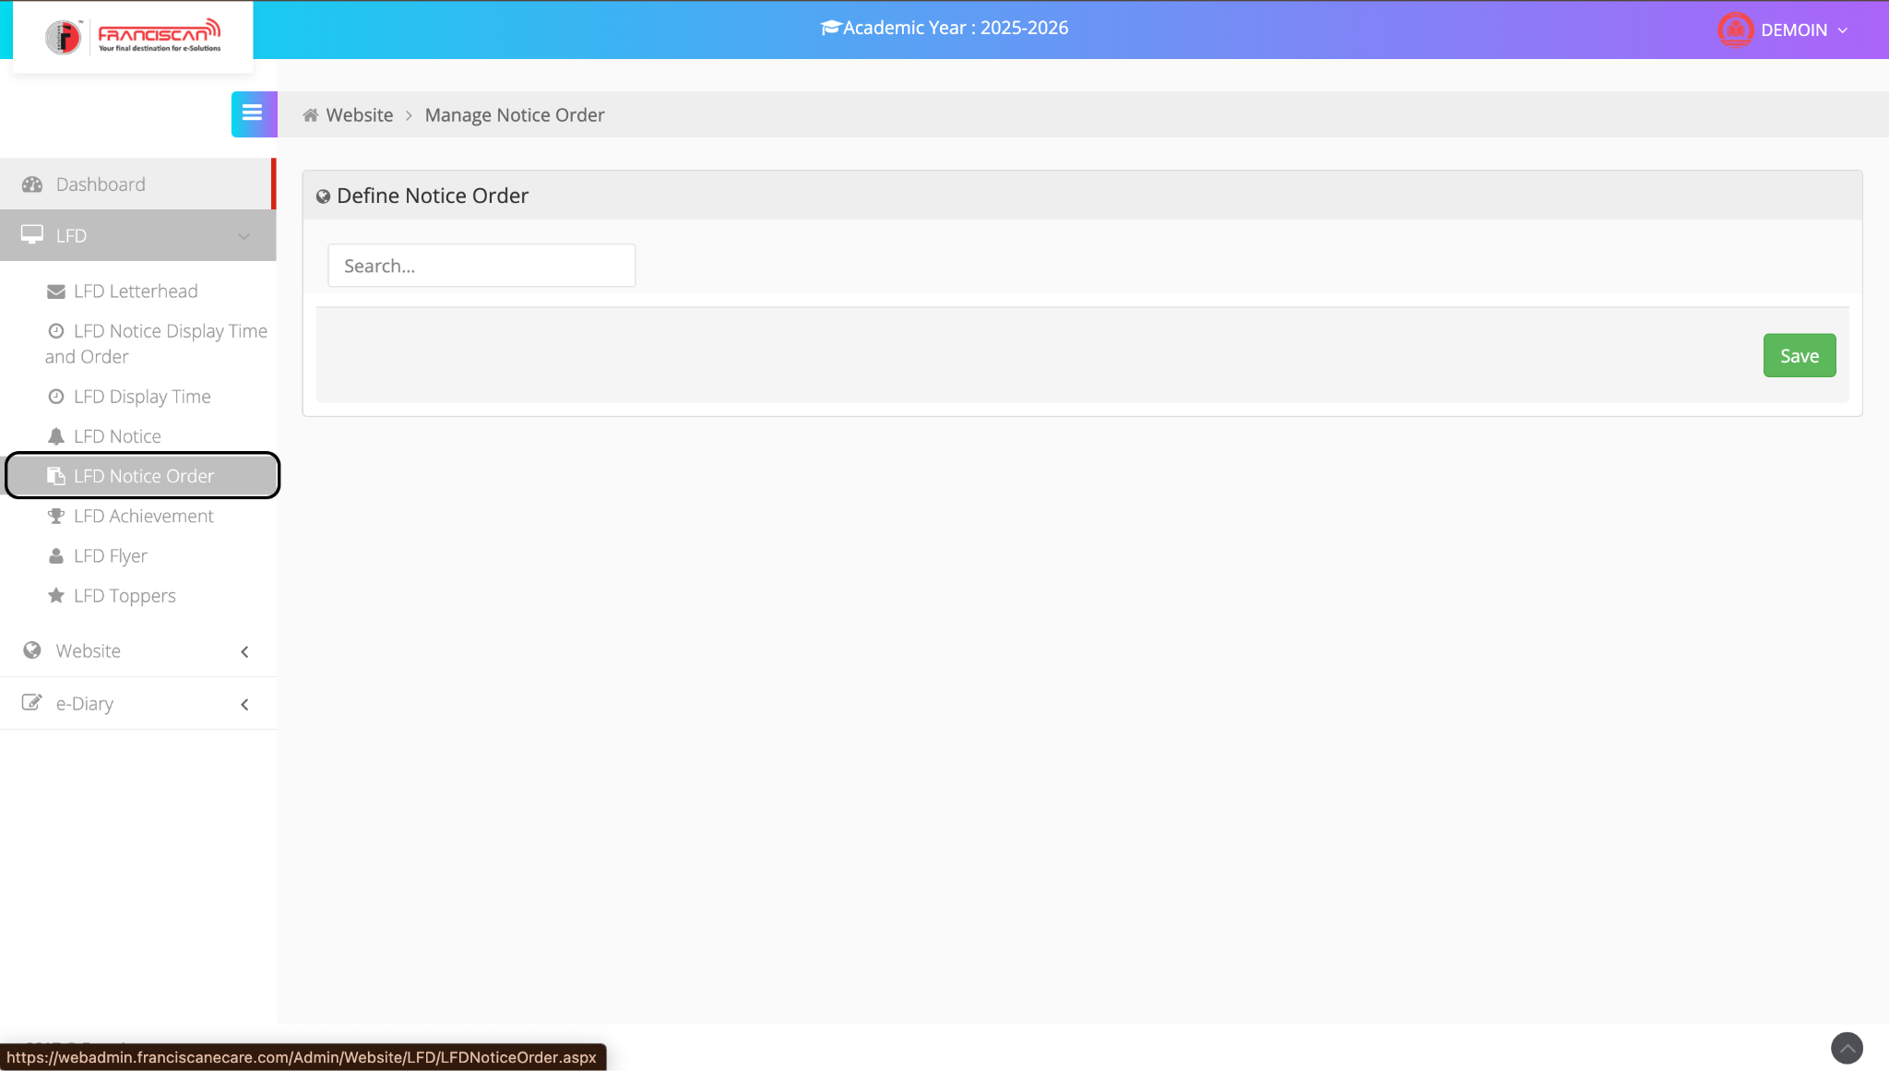

ERP Manual: LFD Notice Order
Module: LFD
Page Name: Define Notice Order
Purpose: To set the order in which notices appear on the Large Format Display (LFD) screen.

Instructions:
- Navigation:
  - From the left sidebar, go to LFD.
  - Click on LFD Notice Order.
- Define Order:
  - Use the Search box to locate a specific notice.
  - Assign or update the display order for each notice as needed.
- Save Order:
  - Click Save to apply the new notice order.

1.6Define LFD Achievement
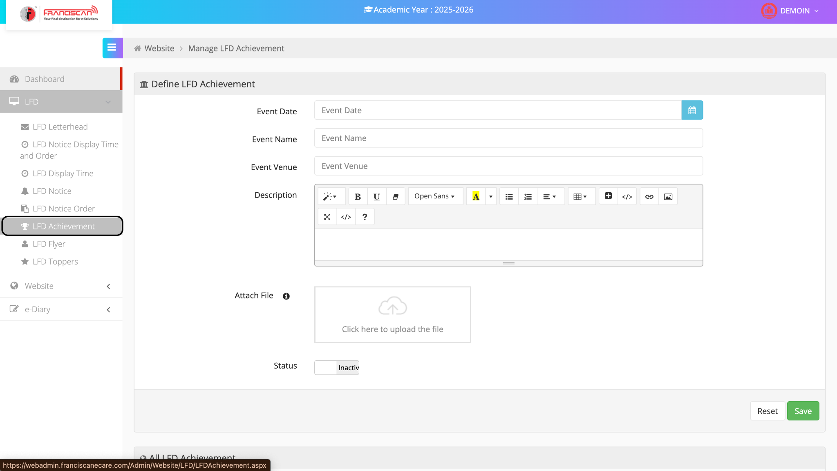

ERP Manual: LFD Achievement
Module: LFD
Page Name: Define LFD Achievement
Purpose: To showcase student or school achievements on the Large Format Display (LFD) screen.

Steps to Add an Achievement:
- Navigation:
  - Go to LFD from the left menu.
  - Click on LFD Achievement.
- Enter Achievement Details:
  - Event Date: Select the date of the event using the calendar icon.
  - Event Name: Enter the title or name of the event.
  - Event Venue: Mention where the event was held.
  - Description: Provide details about the achievement using the rich text editor.
  - Attach File: Upload a related image or document (e.g., certificate or photo).
- Set Status:
  - Toggle Status to Active to display the achievement on LFD.
- Save or Reset:
  - Click Save to publish the achievement.
  - Click Reset to clear all fields.

1.7Define LFD Flyer
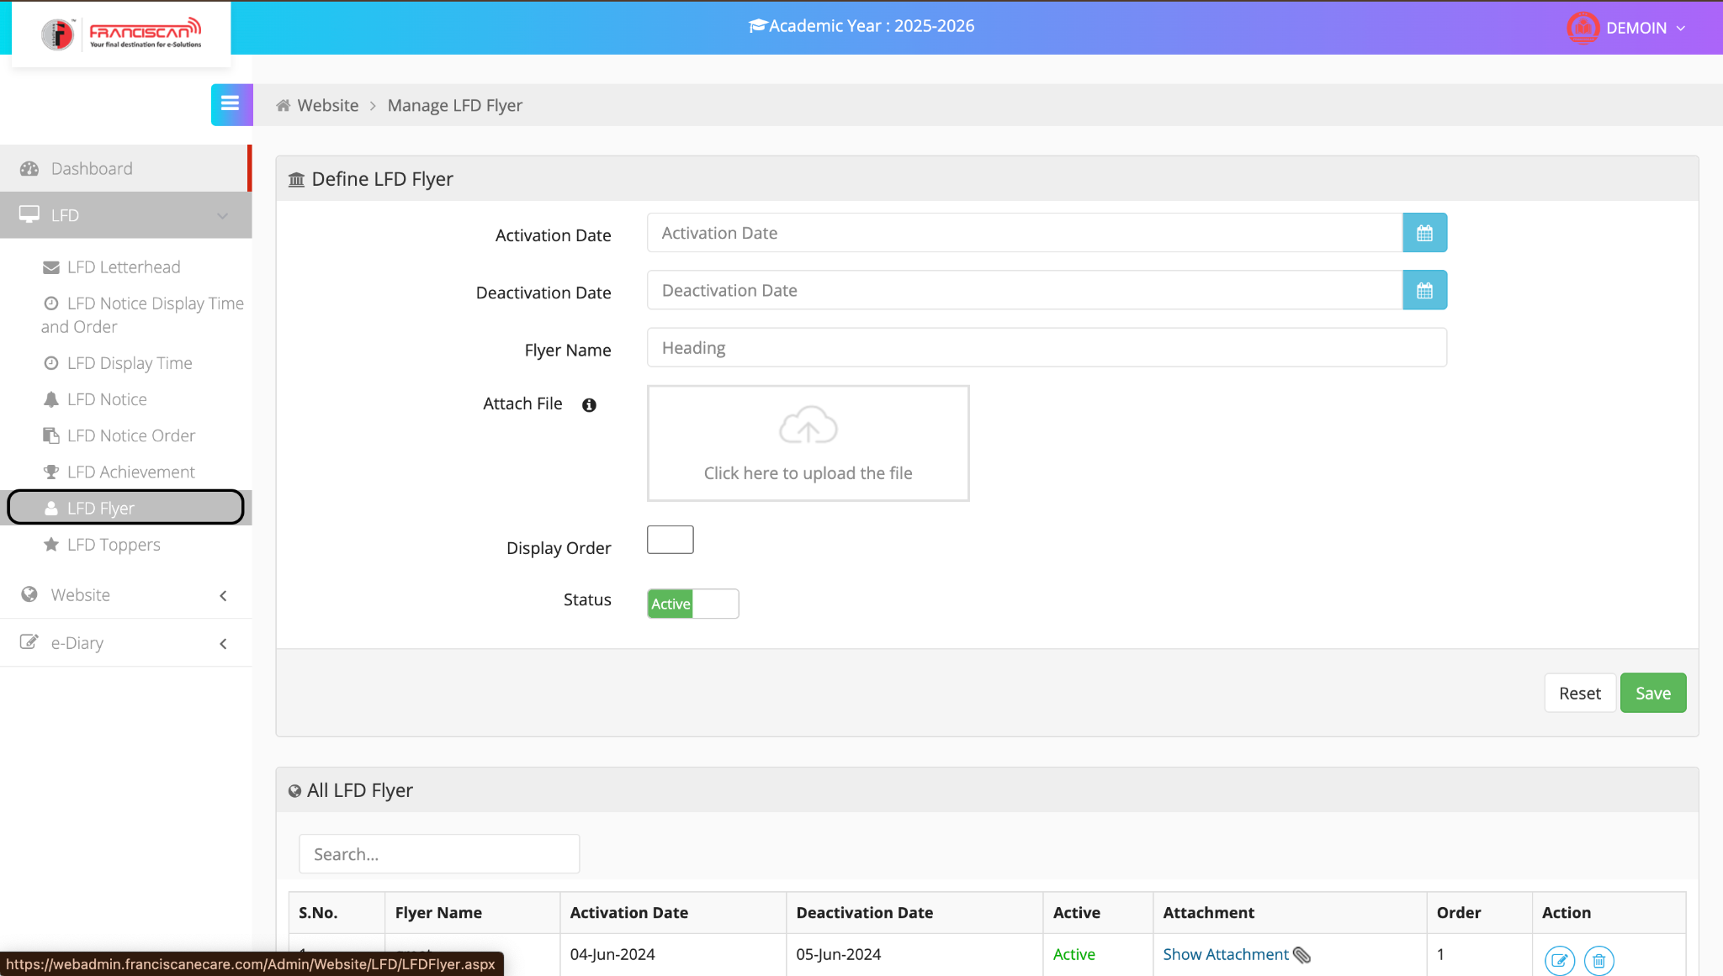

ERP Manual: LFD Flyer
Module: LFD
Page Name: Define LFD Flyer
Purpose: To upload and schedule flyers for display on the Large Format Display (LFD) screen.

Steps to Add a Flyer:
- Navigation:
  - Go to LFD from the left-hand menu.
  - Click on LFD Flyer.
- Enter Flyer Details:
  - Activation Date: Select the date from when the flyer should be visible.
  - Deactivation Date: Choose the end date for flyer visibility.
  - Flyer Name: Enter a suitable heading/title for the flyer.
  - Attach File: Upload the flyer file (e.g., image or PDF).
  - Display Order: Define the order in which the flyer should appear on the screen.
- Set Status:
  - Toggle Status to Active to enable the flyer for display.
- Save or Reset:
  - Click Save to publish the flyer.
  - Click Reset to clear the form.

View or Manage Flyers:
At the bottom of the page, use the All LFD Flyer table to:
- View current flyers along with activation/deactivation dates.
- Check status, view attachments, or perform actions like edit or delete.

1.8Define LFD TOPPERS
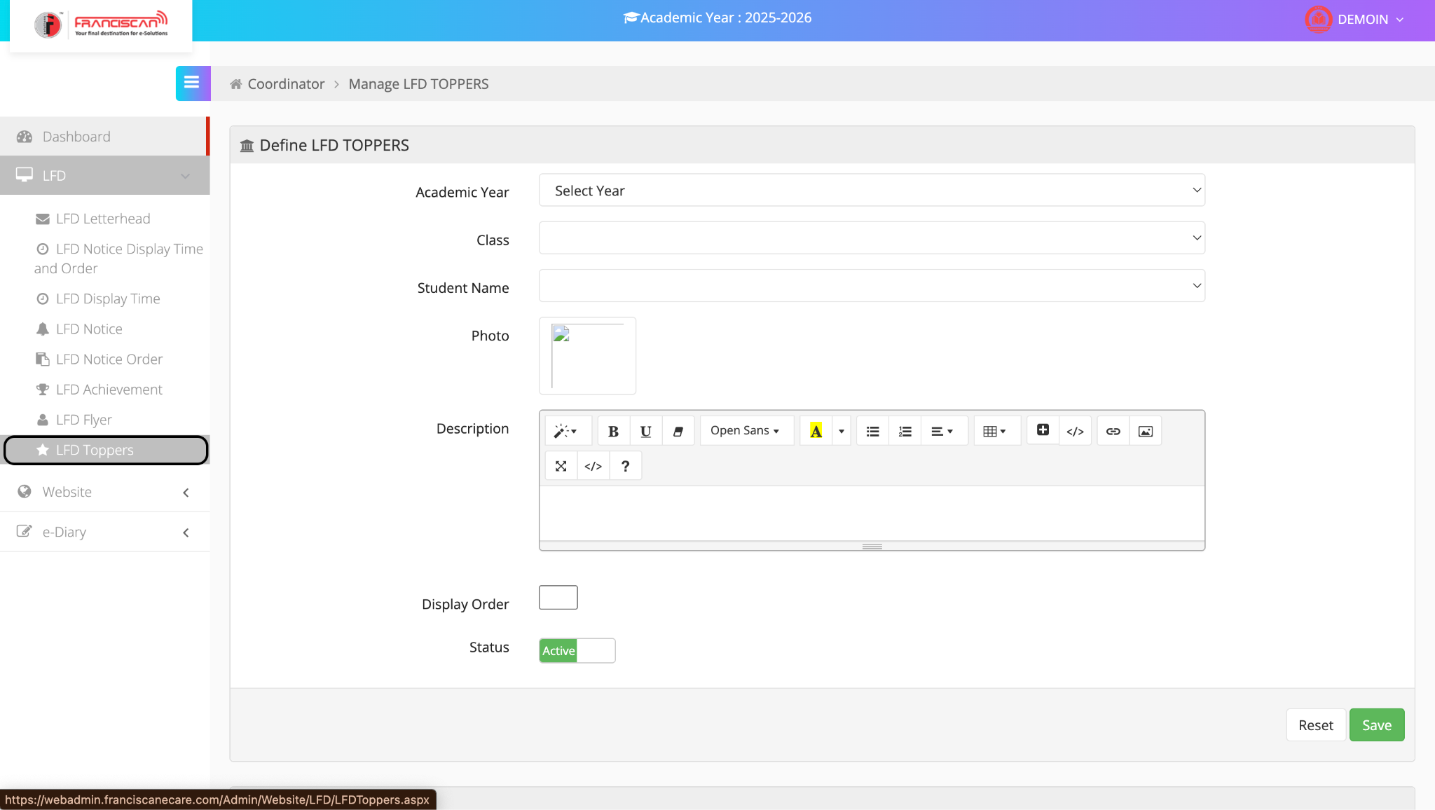

ERP Manual: LFD Toppers
Module: LFD
Page Name: Define LFD Toppers
Purpose: To highlight academic toppers on the Large Format Display (LFD) screen.

Steps to Add a Topper:
- Navigation:
  - Go to LFD in the left sidebar.
  - Click on LFD Toppers.
- Fill in Topper Details:
  - Academic Year: Select the academic session from the dropdown.
  - Class: Choose the class to which the student belongs.
  - Student Name: Select the topper’s name from the list.
  - Photo: Upload the student’s photo.
  - Description: Enter details such as marks, rank, or special achievements using the rich text editor.
  - Display Order: Set the sequence number for display on the LFD.
- Set Status:
  - Toggle the Status to Active to make the entry visible on the LFD screen.
- Save or Reset:
  - Click Save to publish the topper's profile.
  - Click Reset to clear the form.

2.WEBSITE
2.1Add Event
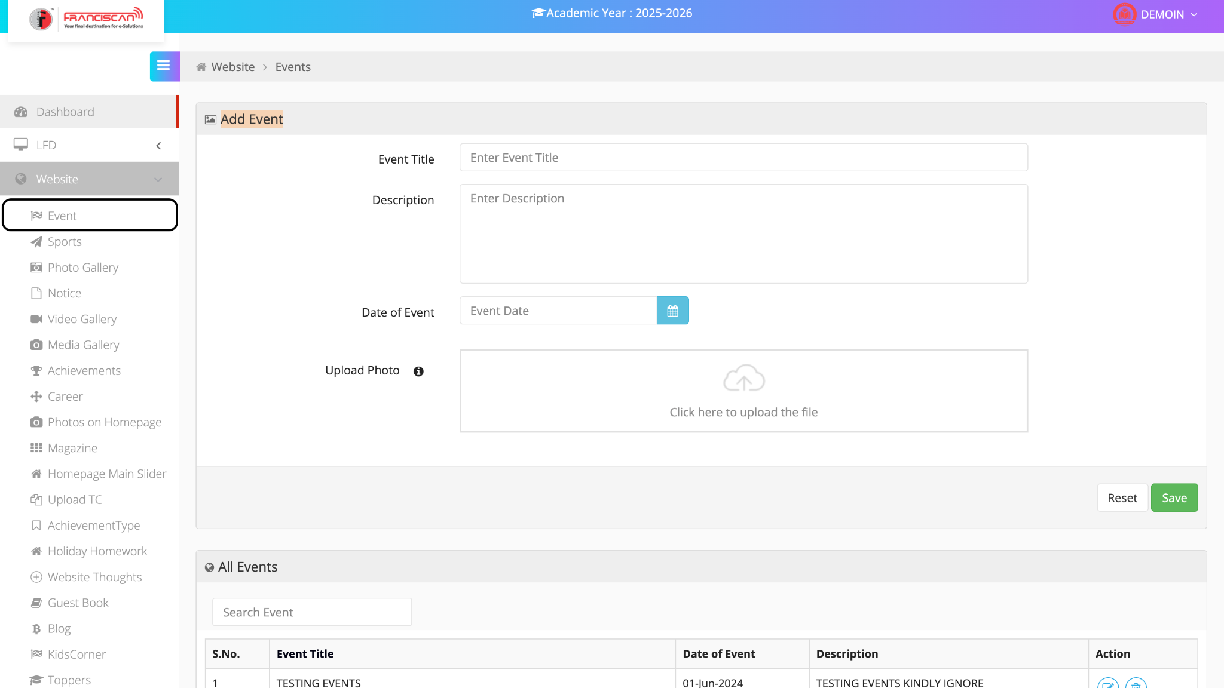

📘 ERP Manual: Add Event (Website Module)

📍 Page Location:
Menu > Website > Event

🎯 Purpose:
This page is used to add new school events that will be displayed on the school's website.

📝 Steps to Add a New Event:
- Event Title
➤ Enter the name of the event.
(Example: "Annual Day Celebration")
- Description
➤ Write a short summary or details about the event.
- Date of Event
➤ Click on the calendar icon and select the event date.
- Upload Photo
➤ Click on the box to upload an image related to the event (e.g., banner or photo).

✅ Save or Reset:
- Save: Click to submit and save the event.
- Reset: Clears the form fields.

📋 View All Events:
The bottom table lists all existing events with:
- Event Title
- Date of Event
- Description
- Action Buttons (Edit / Delete)

2.2Define Sports
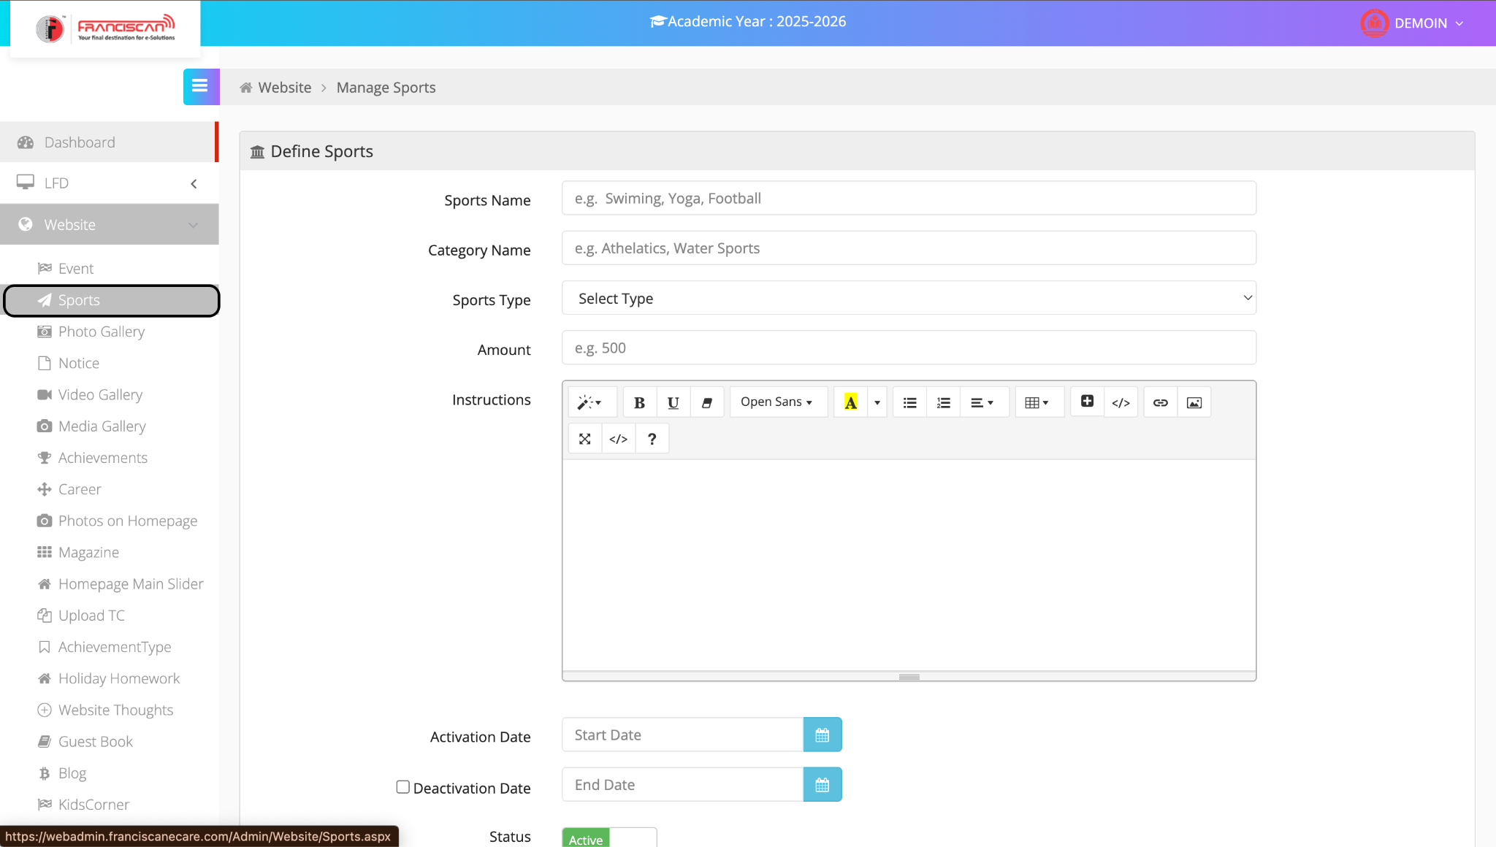

📘 ERP Manual: Define Sports (Website Module)

📍 Page Location:
Menu > Website > Sports

🎯 Purpose:
To define and manage different sports activities for the school website.

📝 Steps to Add or Edit Sports:
- Sports Name
➤ Enter the name(s) of the sport(s).
(Example: Swimming, Yoga, Football)
- Category Name
➤ Mention the category.
(Example: Athletics, Water Sports)
- Sports Type
➤ Select the type from the dropdown.
(Options depend on system configuration)
- Amount
➤ Enter any fee or amount, if applicable.
(Example: 500)
- Instructions
➤ Add any special notes, requirements, or rules for the sport.
(Rich-text editor supports formatting)
- Activation Date
➤ Select the date from which the sport will be available.
- Deactivation Date (Optional)
➤ Check the box and select the end date if the sport is temporary.
- Status
➤ Toggle to set the status as Active or Inactive.

✅ Actions:
- Save button (not visible in screenshot) is used to submit the form.
- Existing sports records can be managed below (not visible in this view).

2.3Add Album
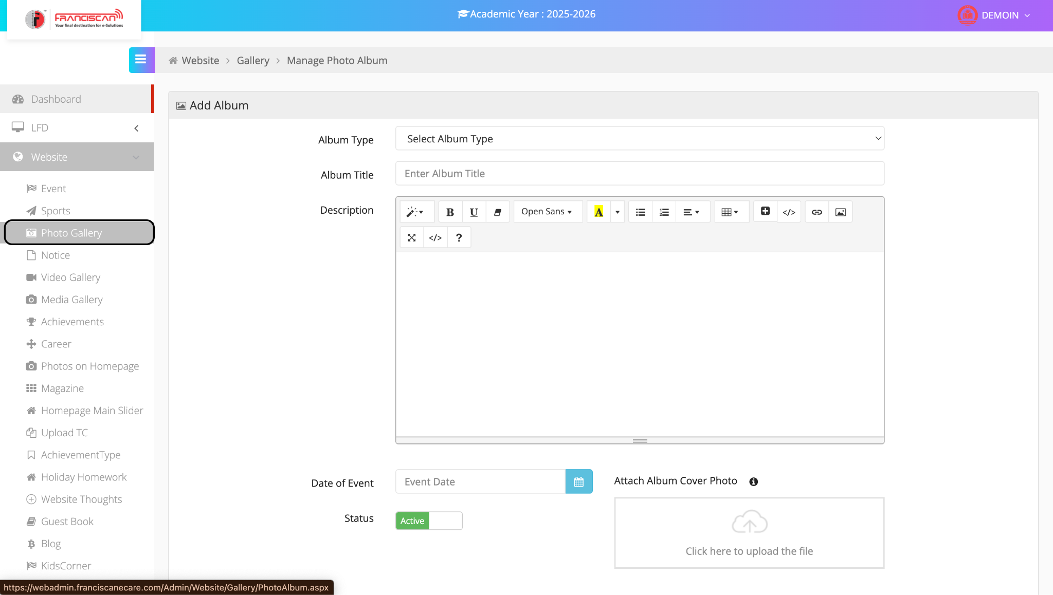

📘 ERP Manual: Manage Photo Album (Website Module)

📍 Page Location:
Menu > Website > Photo Gallery

🎯 Purpose:
To create and manage photo albums that showcase school events and activities on the website.

📝 Steps to Add a New Photo Album:
- Album Type
➤ Select the type of album from the dropdown list.
(Example: Annual Function, Sports Day)
- Album Title
➤ Enter a title for the album.
(Example: Independence Day Celebration 2024)
- Description
➤ Add a brief description of the event or content of the album.
(The editor supports rich text formatting)
- Date of Event
➤ Choose the date on which the event occurred.
- Attach Album Cover Photo
➤ Click the upload box to add a cover photo that will represent the album.
- Status
➤ Set the album to Active or Inactive using the toggle switch.

✅ Final Step:
- Click the Save button (not visible in the screenshot) to submit the album to the photo gallery.

2.4Add News/Notice
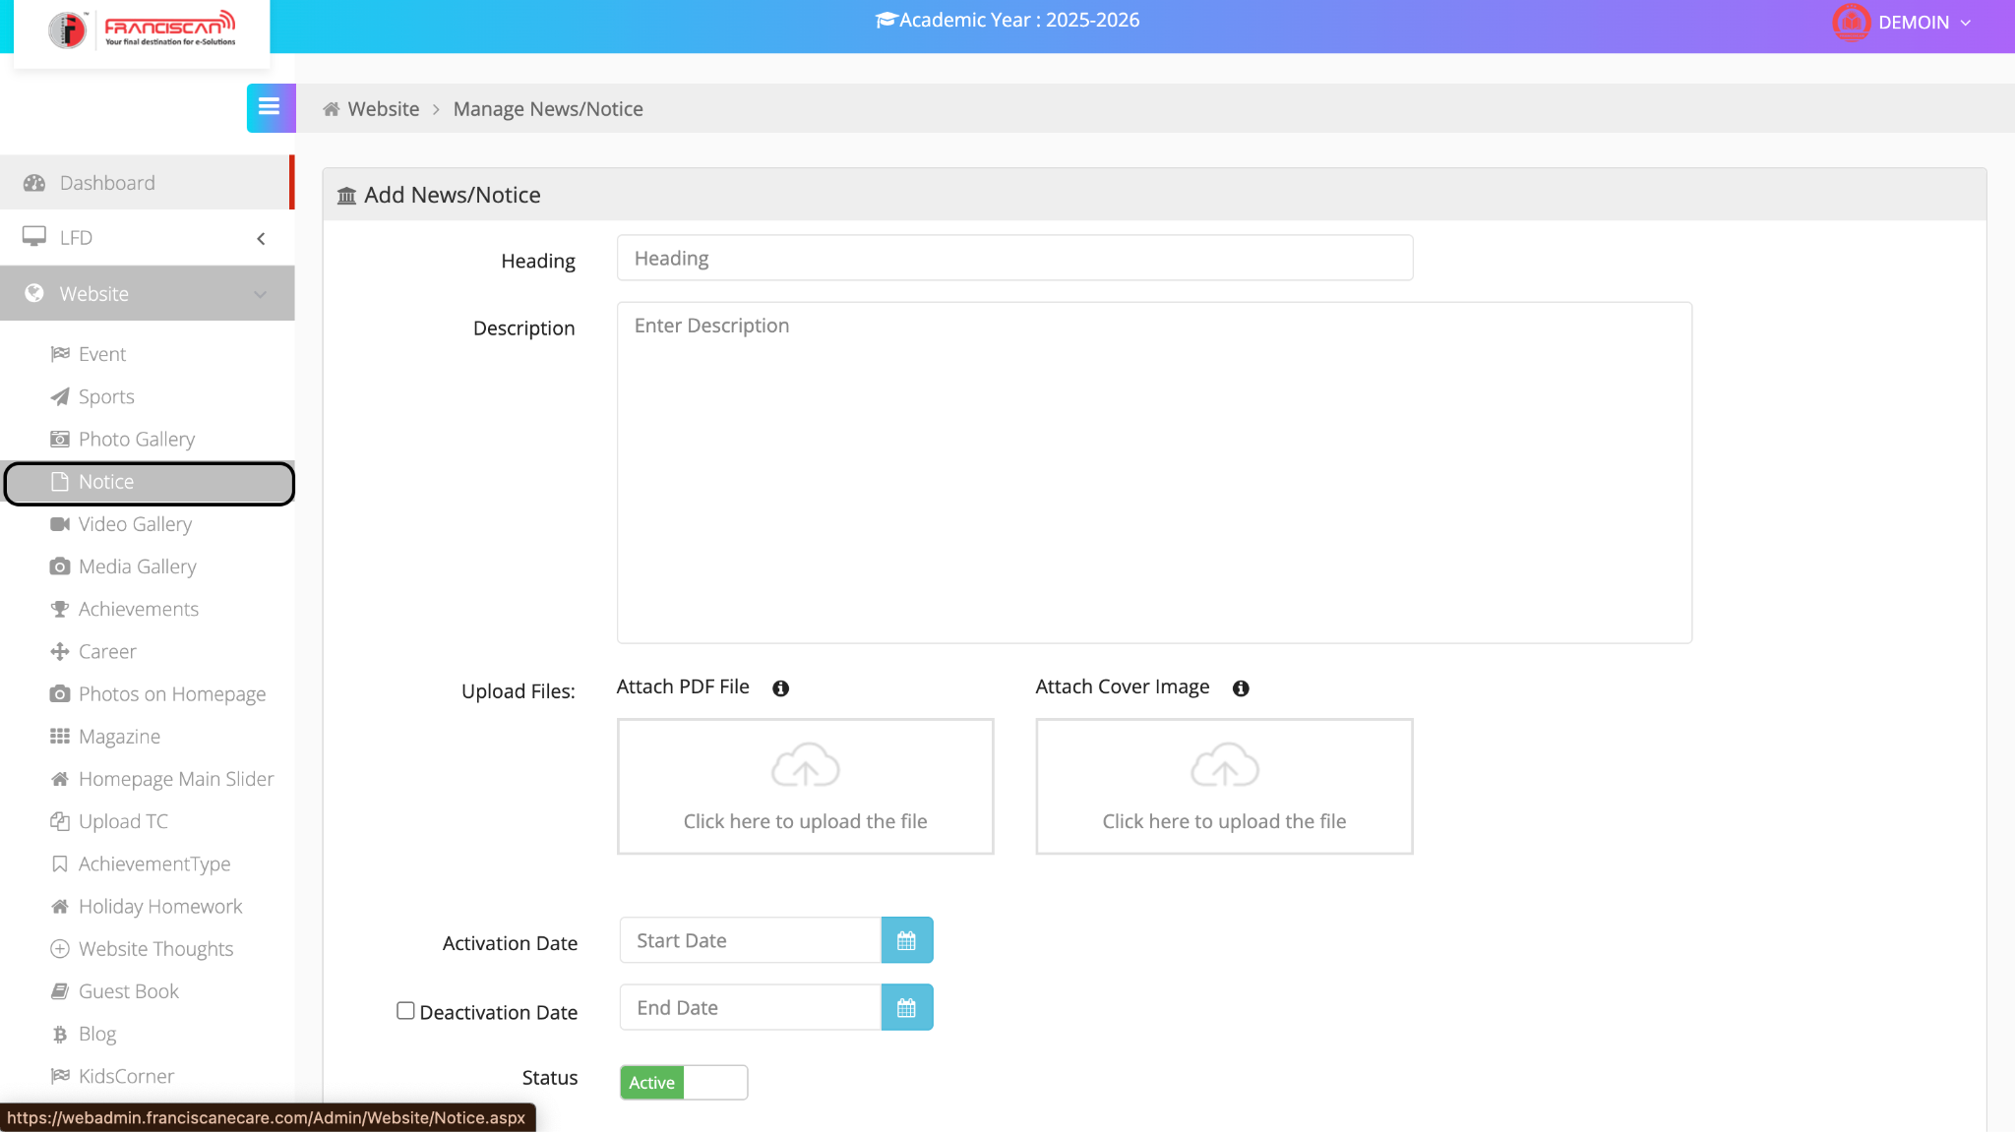

📘 ERP Manual: Add News/Notice (Website Module)

📍 Page Location:
Menu > Website > Notice

🎯 Purpose:
To create and publish school notices or news updates on the website for students, staff, or parents.

📝 Steps to Add a Notice:
- Heading
➤ Enter the title or subject of the notice.
(Example: “PTM Schedule” or “Exam Time Table Released”)
- Description
➤ Write the detailed content of the notice.
(You can enter important instructions, dates, or information here.)
- Attach PDF File
➤ Upload a notice in PDF format if needed (e.g., circulars, schedules).
- Attach Cover Image
➤ Upload an image if you want to display a visual cover for the notice.
- Activation Date
➤ Select the date from when the notice should be visible on the site.
- Deactivation Date (Optional)
➤ If needed, set an end date to remove the notice automatically.
- Status
➤ Keep it Active to make the notice live.

✅ Final Step:
- Click the Save button (not visible in the screenshot) to publish the notice.

2.5Add Video Album
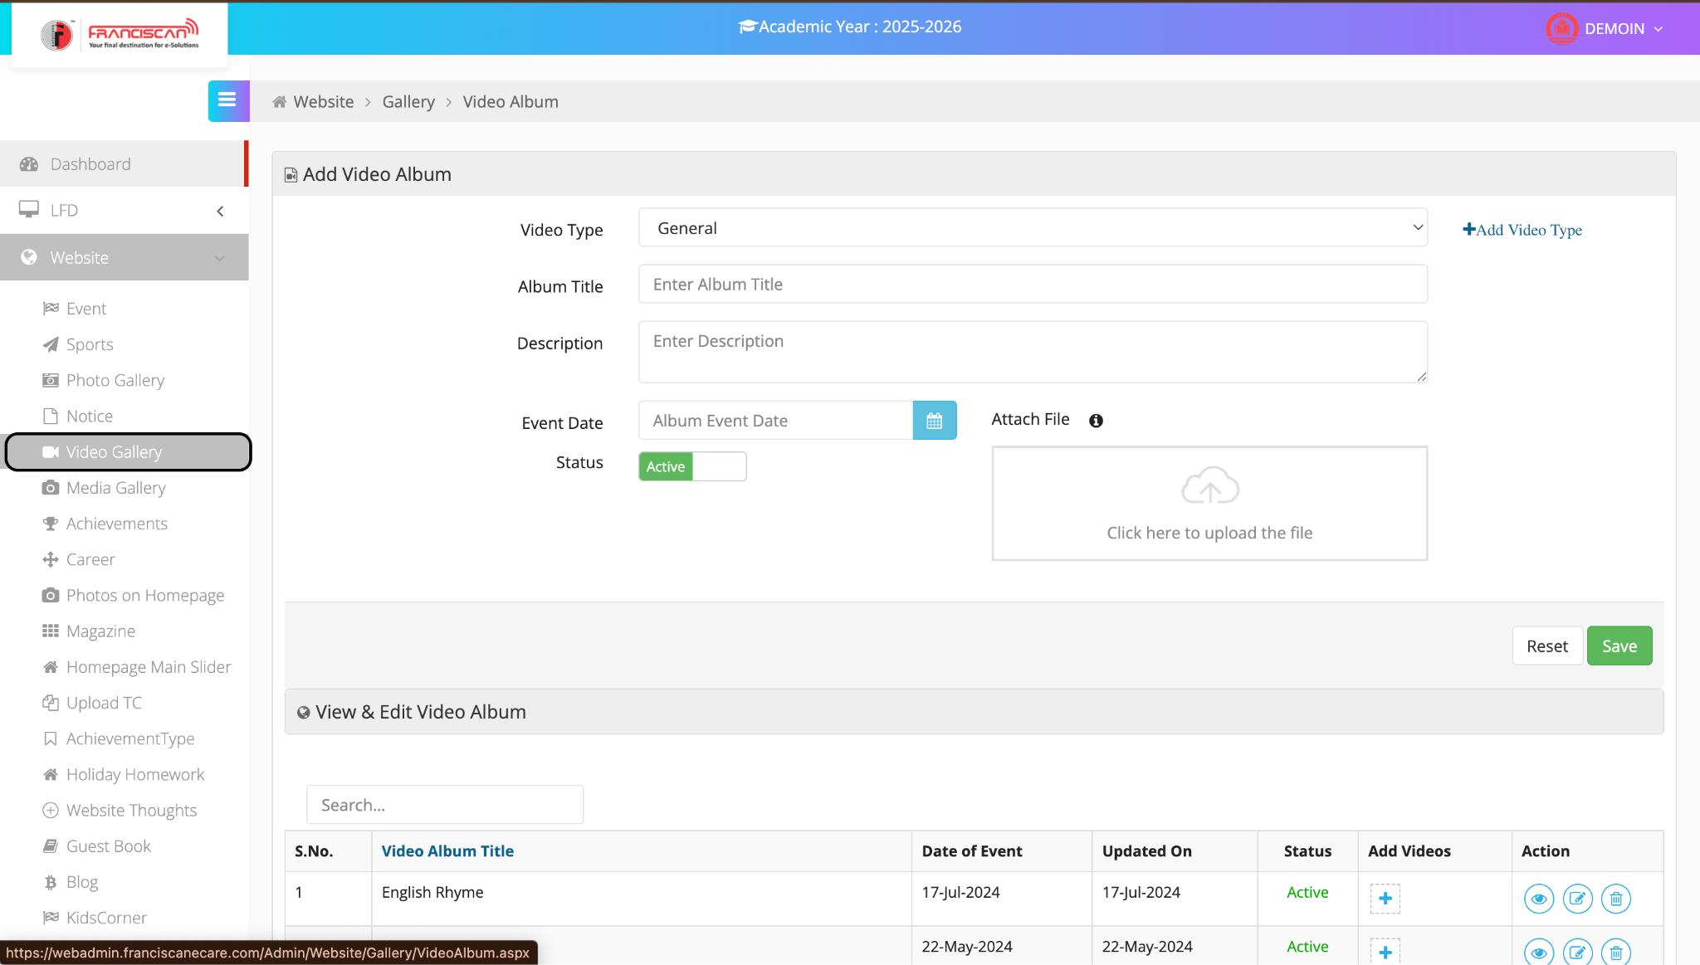

📘 ERP Manual: Add Video Album (Website Module)

📍 Page Location:
Menu > Website > Video Gallery

🎯 Purpose:
To create and manage video albums for showcasing school events, activities, or programs.

📝 Steps to Add a Video Album:
- Video Type
➤ Select the category/type of the video.
(E.g., Annual Function, Sports Day, General)
➤ Click on “+Add Video Type” if you want to create a new type.
- Album Title
➤ Enter the name of the video album.
(Example: “English Rhyme Day” or “Annual Sports Meet”)
- Description
➤ Provide a brief description of the event or content in the video.
- Event Date
➤ Choose the date when the event was held.
- Attach File
➤ Upload the video file or thumbnail/cover image.
(Click inside the box to upload the file.)
- Status
➤ Set the album status as Active to make it visible on the site.

✅ Final Step:
- Click Save to publish the album.
- Click Reset to clear the form if needed.

🔄 View & Edit Section (Below Form)
- View Album List: Shows all uploaded video albums with:
  - Date of Event
  - Last Updated On
  - Status (Active/Inactive)
- Actions Available:
  - 👁 View
  - ✏ Edit
  - 🗑 Delete
  - ➕ Add Videos to the Album

2.6Add Media Album
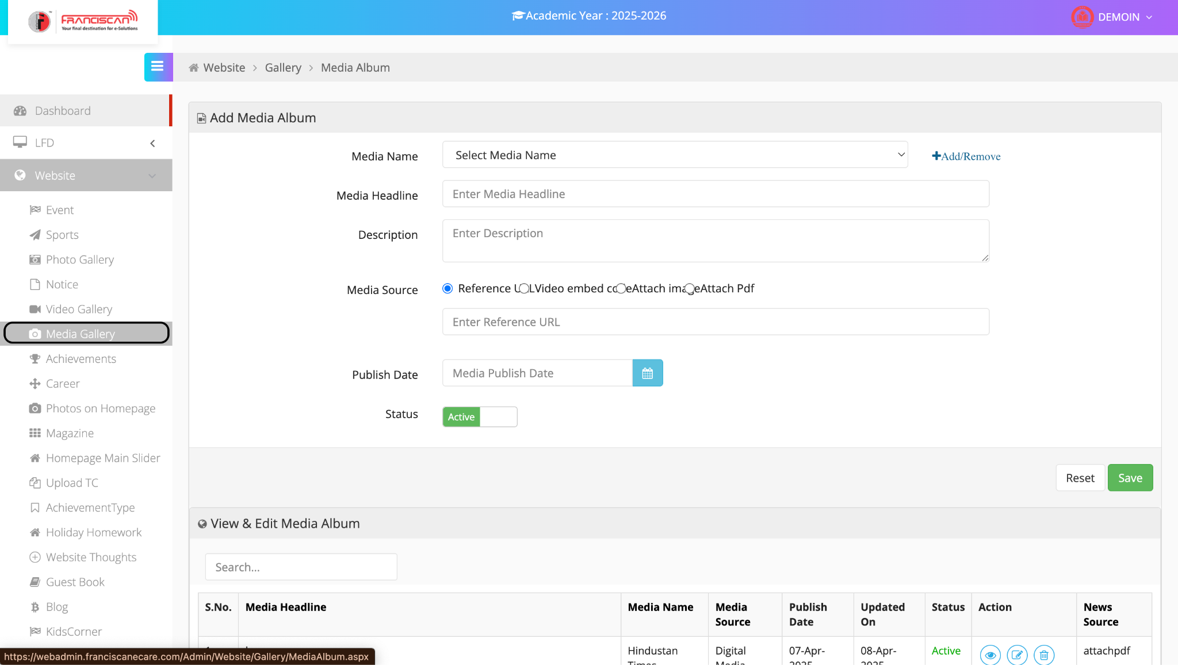

📘 ERP Manual: Add Media Album (Website Module)

📍 Page Location:
Menu > Website > Media Gallery

🎯 Purpose:
To upload and display news/media coverage of school events on the website, using reference links, video embeds, images, or PDF attachments.

📝 Steps to Add a Media Album:
- Media Name
➤ Select the source of the media (e.g., Newspaper, TV channel).
➤ Click +Add/Remove to manage media names if needed.
- Media Headline
➤ Enter the headline/title of the media item.
(Example: “School Featured in Hindustan Times”)
- Description
➤ Provide a short summary or description of the media coverage.
- Media Source
➤ Choose how the media will be displayed:
  - Reference: Use an external URL (paste in the field below)
  - Video Embed Code
  - Attach Image
  - Attach PDF
- Publish Date
➤ Select the date when this media was published.
- Status
➤ Set as Active to make it visible on the website.

✅ Final Step:
- Click Save to publish the media album.
- Click Reset to clear the form.

🔄 View & Edit Media Album (Below Form)
- Media List displays:
  - Media Headline
  - Media Name
  - Source Type
  - Publish & Update Dates
  - Status
  - News Source Type (e.g., attachpdf)
- Action Icons:
  - 👁 View
  - ✏ Edit
  - 🗑 Delete

2.7Upload Achievement
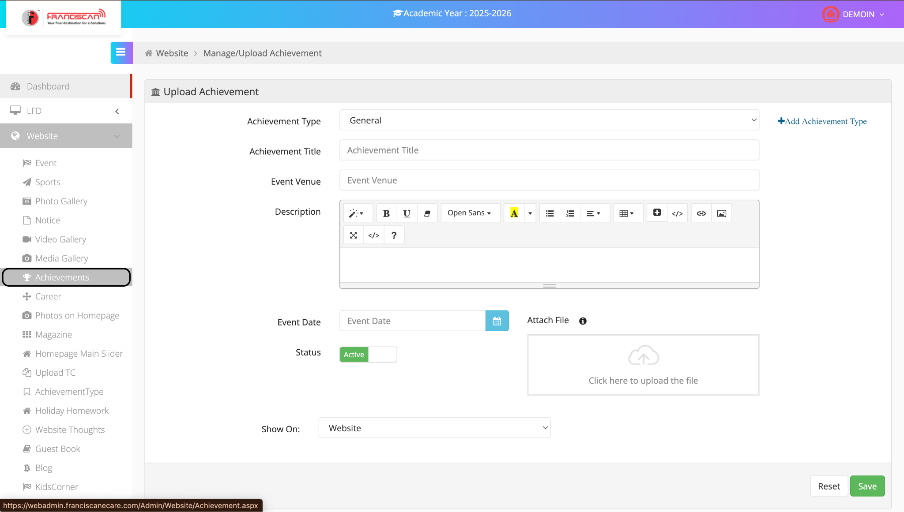

📘 ERP Manual: Upload Achievement (Website Module)

📍 Page Location:
Menu > Website > Achievements

🎯 Purpose:
To add, manage, and publish student or school achievements on the website, visible to parents and the school community.

📝 Steps to Upload an Achievement:
- Achievement Type
➤ Choose the category (e.g., Sports, Academics, Cultural).
➤ Click +Add Achievement Type to create new types.
- Achievement Title
➤ Enter the title or name of the achievement.
(Example: “State Level Chess Champion”)
- Event Venue
➤ Type the location where the event took place.
(Example: “Delhi Public School Auditorium”)
- Description
➤ Enter detailed information about the achievement.
➤ Use text formatting tools for emphasis, links, or images.
- Event Date
➤ Select the date when the achievement occurred.
- Attach File
➤ Upload supporting documents or images (certificate, photo, etc.).
- Status
➤ Set as Active to publish on the website.
- Show On
➤ Choose where the achievement will appear (e.g., Website, Portal, Both).

✅ Final Step:
- Click Save to upload the achievement.
- Click Reset to clear the form.

2.8Post Vacancy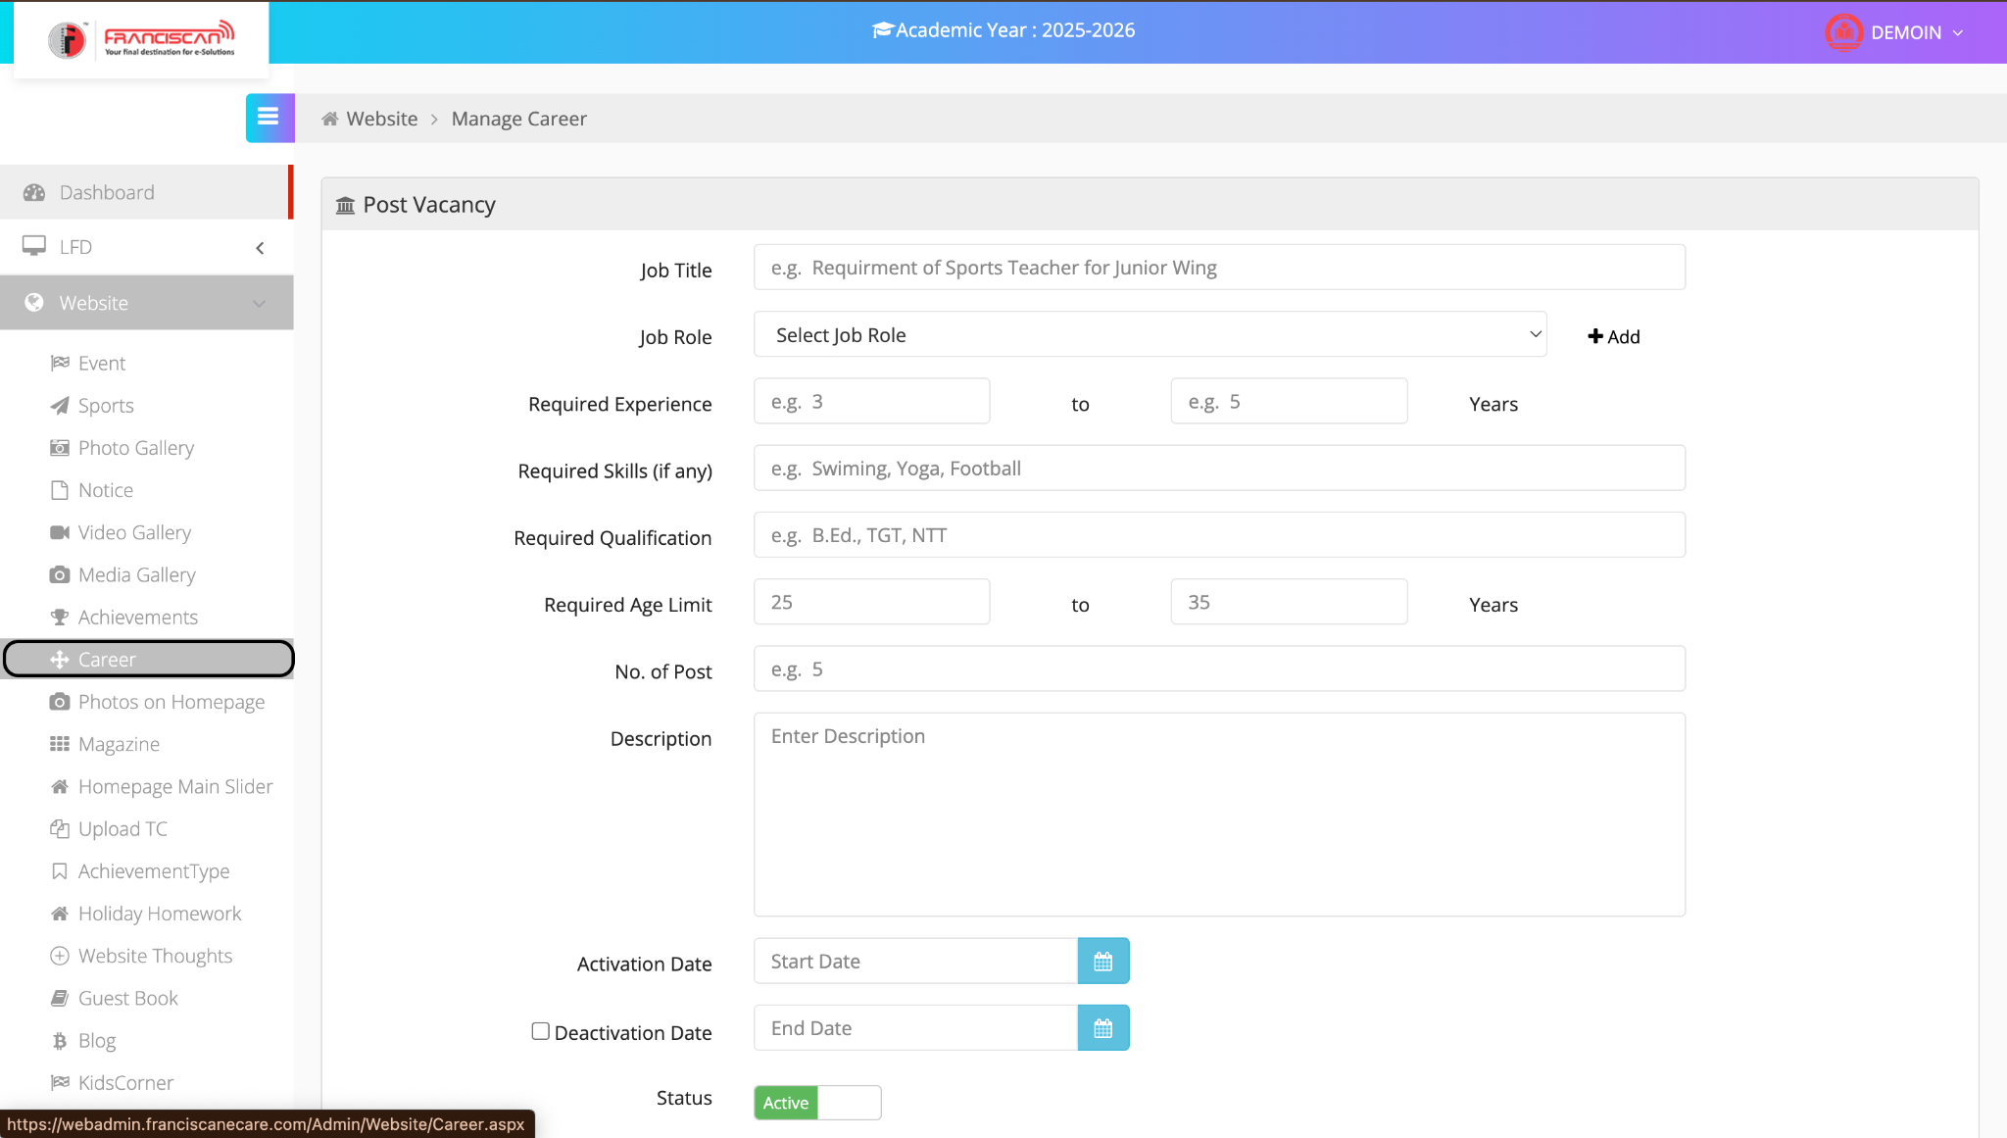

📘 ERP Manual: Post Vacancy (Career Module)

📍 Page Location:
Menu > Website > Career

🎯 Purpose:
To add job openings and recruitment posts for public display on the school website.

📝 Steps to Post a Job Vacancy:
- Job Title
➤ Enter the vacancy title.
(Example: Requirement of Sports Teacher for Junior Wing)
- Job Role
➤ Select a predefined job role from the dropdown.
➤ Click +Add to create a new role if not listed.
- Required Experience
➤ Enter minimum and maximum experience in years.
(Example: 3 to 5 Years)
- Required Skills (if any)
➤ Mention skills related to the post.
(Example: Swimming, Yoga, Football)
- Required Qualification
➤ Enter academic qualifications.
(Example: B.Ed., TGT, NTT)
- Required Age Limit
➤ Specify minimum and maximum age.
(Example: 25 to 35 Years)
- No. of Post
➤ Enter the number of vacancies.
(Example: 5)
- Description
➤ Write full details of the post, including duties and expectations.
- Activation Date
➤ Select the Start Date for vacancy to be shown online.
- Deactivation Date (Optional)
➤ Select End Date to stop showing the vacancy.
- Status
➤ Set to Active to make the post live.

✅ Final Step:
- Click Save to publish the job.
- Click Reset to clear the form.

2.9Select Photo Album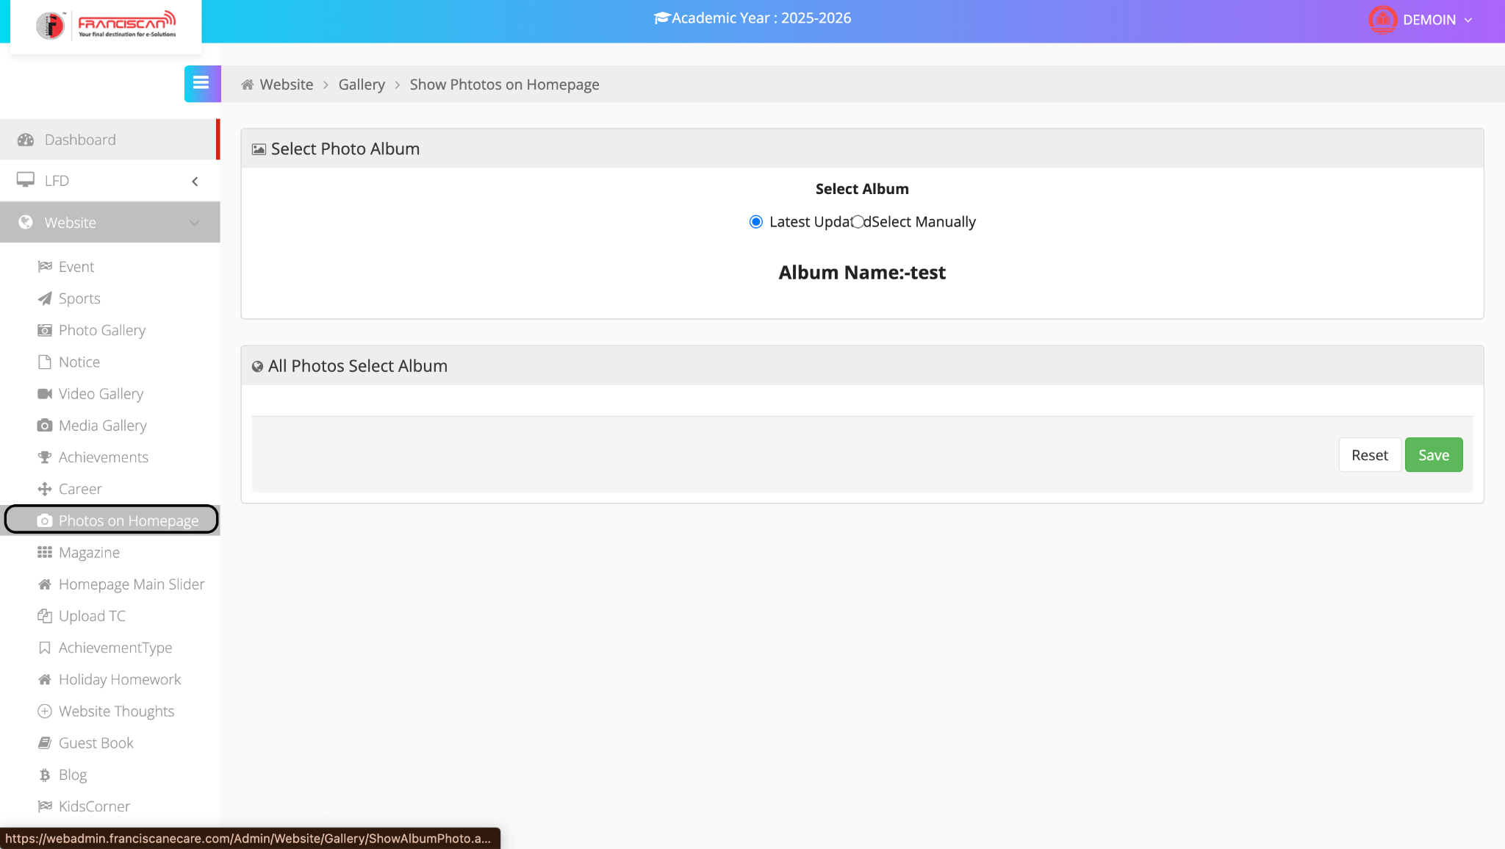

📘 ERP Manual: Photos on Homepage (Gallery Module)

📍 Page Location:
Menu > Website > Photos on Homepage

🎯 Purpose:
To display selected photo albums or images on the homepage of the school website.

📝 Steps to Manage Homepage Photo Display:
- Select Album Mode
➤ Choose how you want to display photos on the homepage:
  - Latest Updated: Automatically shows photos from the most recently updated album.
  - Select Manually: Allows you to choose a specific album.
- Album Name
➤ When selected manually, pick the desired album from the dropdown list.
(Example: Album Name: test)
- All Photos – Select Album
➤ If needed, review or choose another album to manage photos.
- Save or Reset
  - Click Save to apply the changes.
  - Click Reset to clear the selections.

2.10Add E-Magazine/Newsletter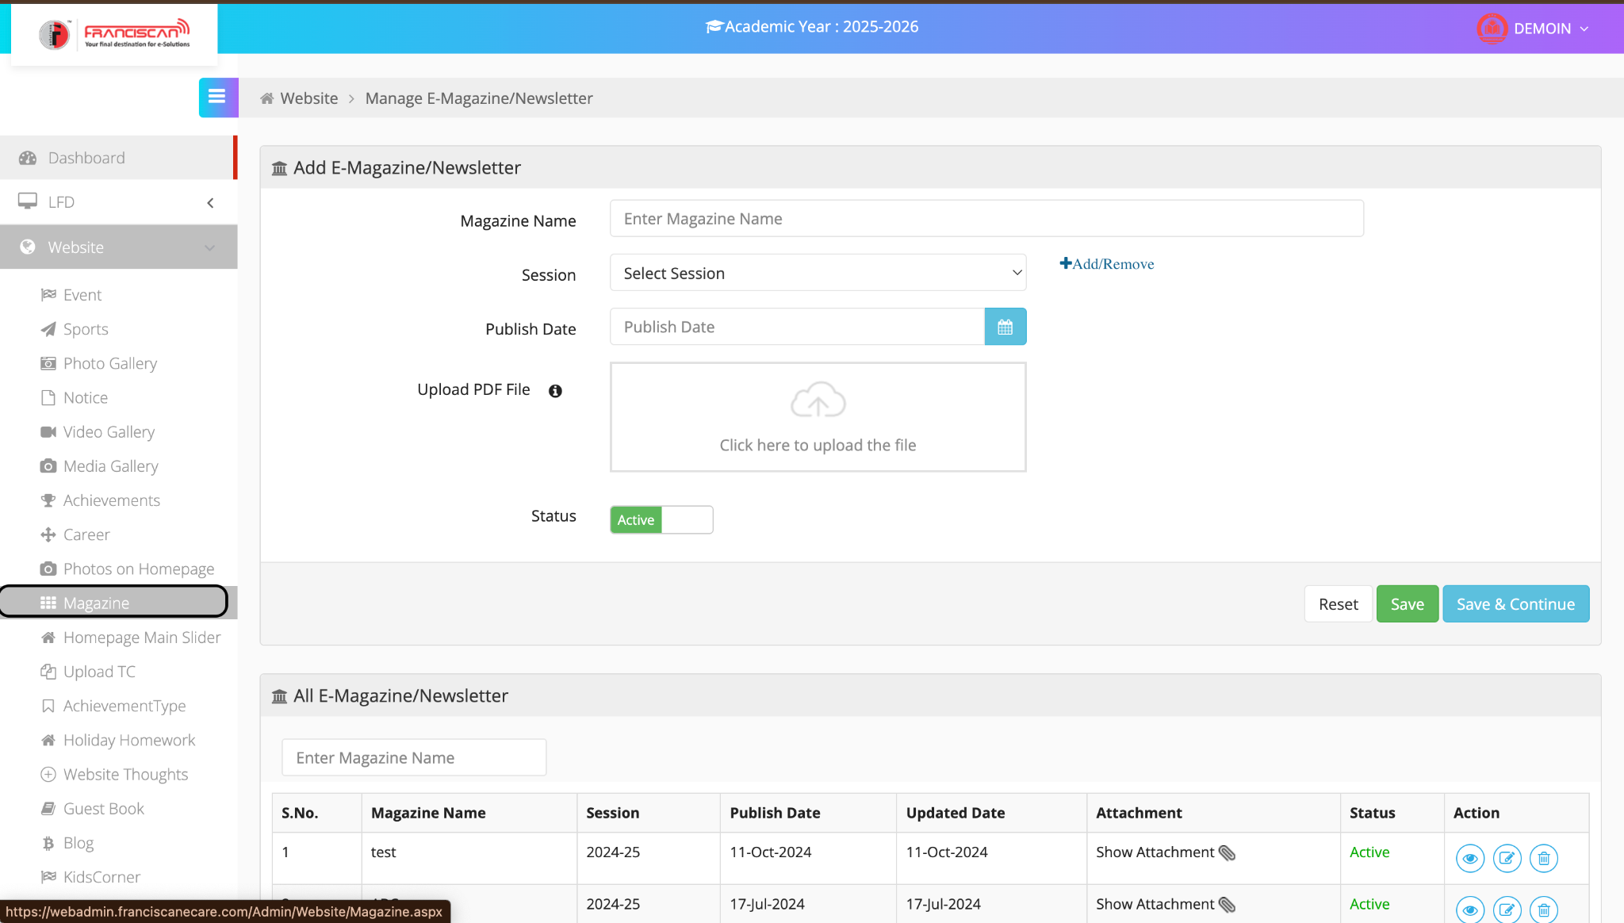

📘 ERP Manual: Manage E-Magazine/Newsletter

📍 Page Location:
Menu > Website > Magazine

🎯 Purpose:
To upload and manage school e-magazines or newsletters in PDF format.

📝 Steps to Add an E-Magazine or Newsletter:
- Magazine Name
➤ Enter the title of the magazine or newsletter. (e.g., "Annual Newsletter")
- Session
➤ Select the relevant academic session.
➤ Use Add/Remove to manage session options if needed.
- Publish Date
➤ Choose the date on which the magazine will be published.
- Upload PDF File
➤ Click on the upload box to select and attach the magazine file (PDF format only).
- Status
➤ Set status to Active to display it on the website.
- Save Options
  - Save: Adds the magazine and returns to the list.
  - Save & Continue: Adds the magazine and keeps the form open for another entry.
  - Reset: Clears the form.

📋 Magazine Listing (Bottom Section)
- View all uploaded magazines with their Session, Publish Date, Attachment, and Status.
- Use action buttons to View, Edit, or Delete existing entries.

2.11Homepage main Slider
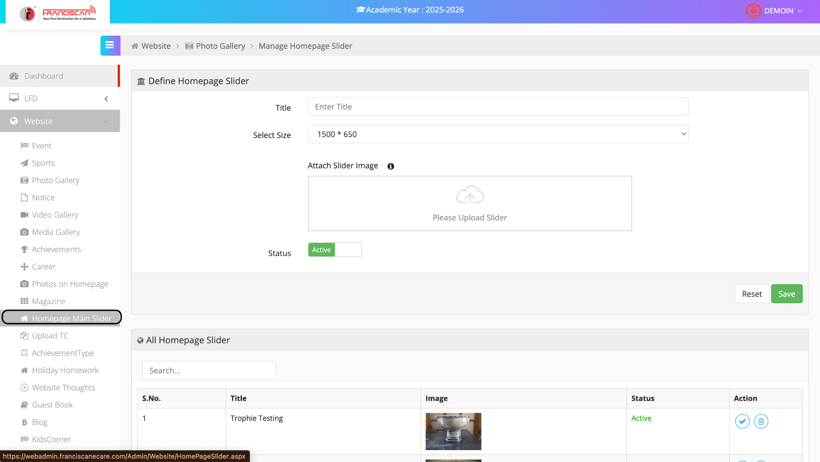

🖼️ ERP Manual: Manage Homepage Slider

📍 Page Location:
Menu > Website > Homepage Main Slider

🎯 Purpose:
To upload and manage image sliders that appear on the homepage of the school website.

📝 Steps to Add a New Homepage Slider Image:
- Title
➤ Enter the title for the slider image. (e.g., “Annual Day Banner”)
- Select Size
➤ Choose the image size from the dropdown. (Default: 1500 × 650 pixels)
➤ Recommended: Upload image of selected dimensions for best display.
- Attach Slider Image
➤ Click on the upload box to attach the image file.
- Status
➤ Set to Active to display the image on the homepage.
- Buttons
  - Save: Add the slider image.
  - Reset: Clear the form.

📋 Slider Image List (Bottom Section)
- Shows all uploaded sliders with:
  - S. No.
  - Title
  - Image Preview
  - Status (Active/Inactive)
  - Actions:
    - ✅ Activate/Deactivate
    - 🗑️ Delete

2.12Upload TC
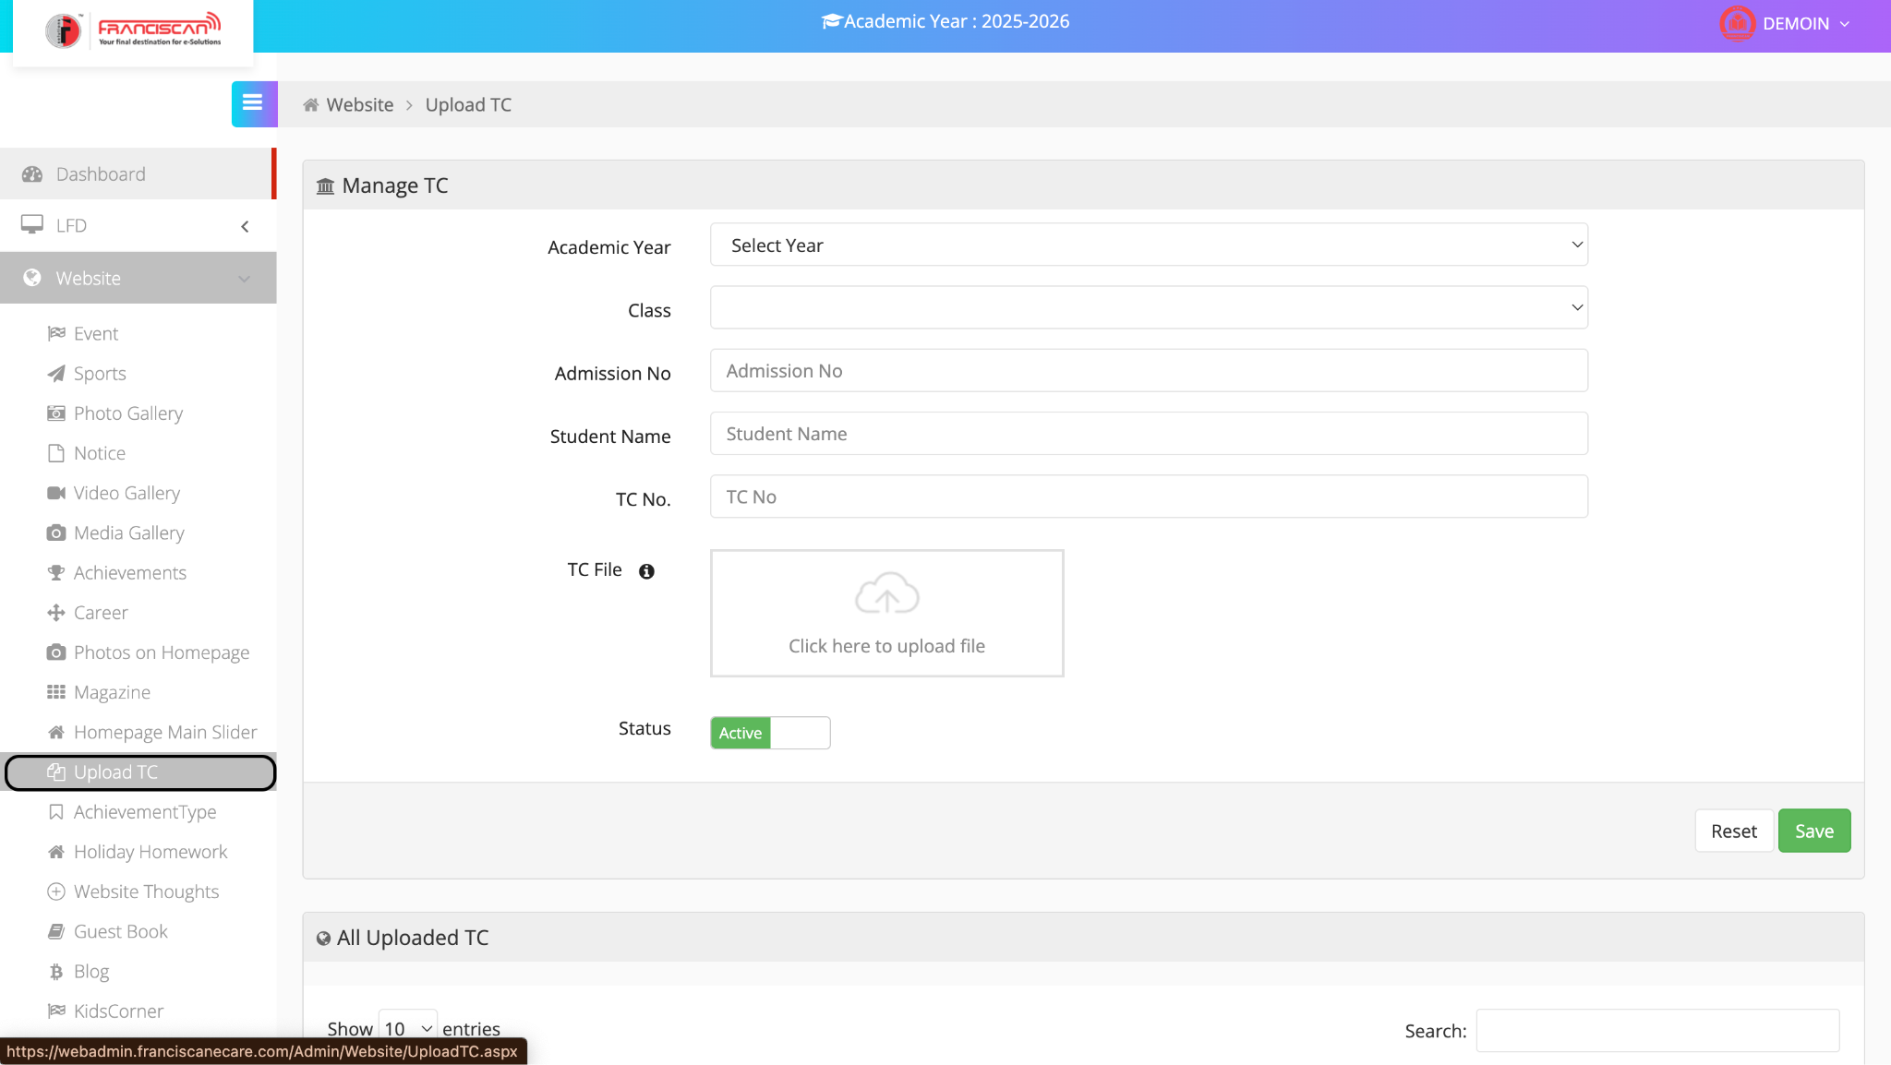

📄 ERP Manual: Upload Transfer Certificate (TC)

📍 Page Location:
Menu > Website > Upload TC

🎯 Purpose:
To upload and manage student Transfer Certificates (TC) on the school website for record and verification.

📝 Steps to Upload a TC
- Academic Year
➤ Select the academic year from the dropdown.
- Class
➤ Enter or select the class the student was enrolled in.
- Admission No
➤ Enter the student's unique admission number.
- Student Name
➤ Enter the full name of the student.
- TC No.
➤ Enter the Transfer Certificate number issued to the student.
- TC File
➤ Click the upload area and attach the TC document (PDF or image format).
- Status
➤ Keep it Active to make the TC visible or available.
- Buttons
  - Save: Save and upload the TC.
  - Reset: Clear all entered fields.

📋 All Uploaded TC (Below Section)
- Displays a searchable list of all uploaded TC entries with:
  - Admission Number
  - Student Name
  - Class
  - TC No.
  - Download/View Link

2.13Achievement type
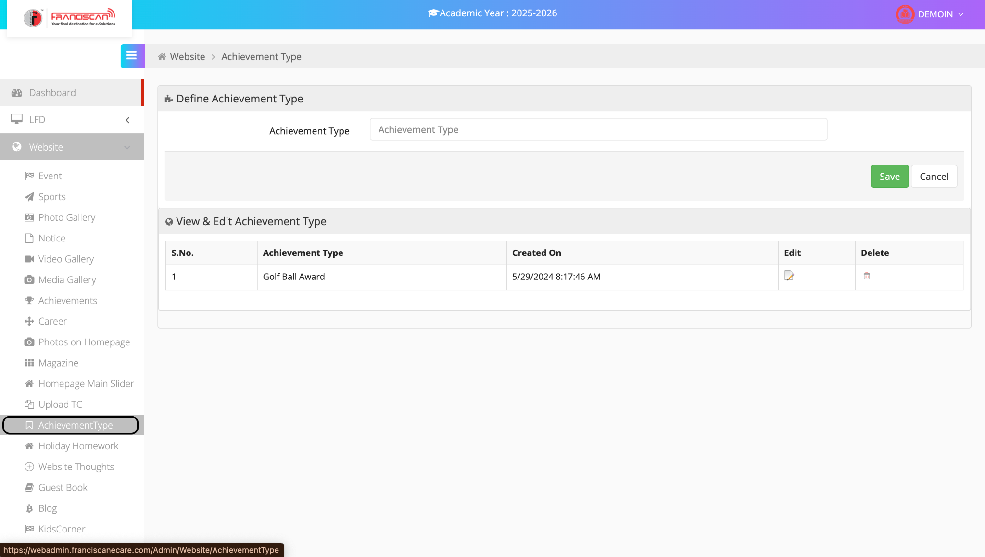

🏆 ERP Manual: Define Achievement Type

📍 Page Location:
Menu > Website > AchievementType

🎯 Purpose:
To create, edit, or delete types of achievements (e.g., awards, certificates) that will be used for student or school recognition records.

📝 Steps to Define a New Achievement Type
- Achievement Type
➤ Enter the name of the achievement (e.g., "Best Performer", "Gold Medalist").
- Buttons
  - Save: Saves the newly added achievement type.
  - Cancel: Clears the input field without saving.

✏️ View & Edit Achievement Type
- Displays a table of all existing achievement types.
- Each entry includes:
  - S. No.
  - Achievement Type
  - Created On timestamp
  - Edit (🖉 icon): Click to modify the achievement name.
  - Delete (🗑 icon): Click to remove the achievement type.

2.14Holiday Homework
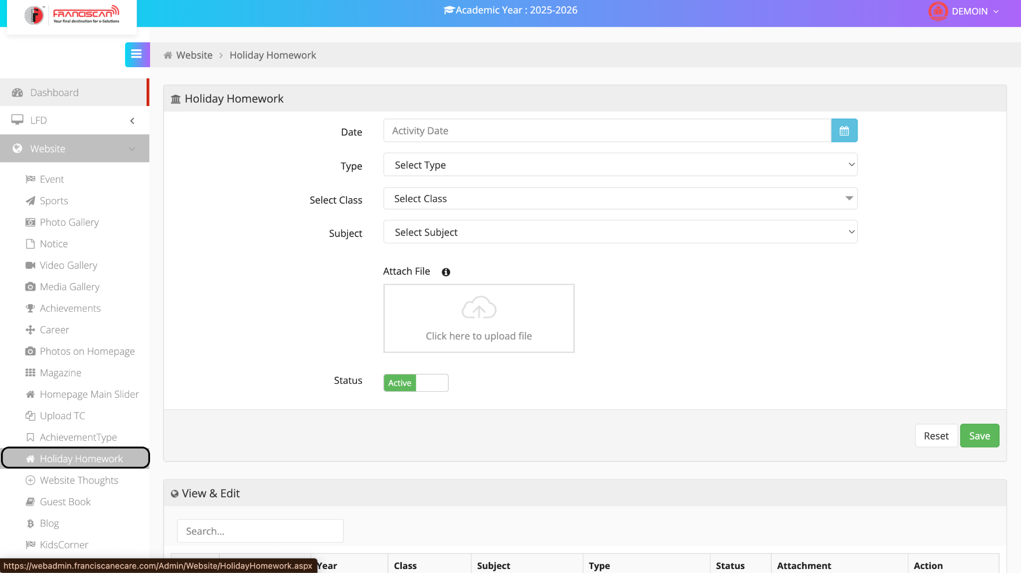

📘 ERP Manual: Holiday Homework Upload

📍 Page Location:
Menu > Website > Holiday Homework

🎯 Purpose:
To upload and manage holiday homework by class and subject.

📝 Steps to Upload Holiday Homework
- Date
➤ Select the date of the activity or when the homework is assigned.
- Type
➤ Choose the type of homework (e.g., Summer, Winter, Diwali).
- Select Class
➤ Choose the class for which the homework is assigned.
- Subject
➤ Choose the subject (e.g., English, Math, Science).
- Attach File
➤ Click the box to upload the homework file (PDF, Word, etc.).
- Status
➤ Set the homework status:
  - Active: Visible to users.
  - Inactive: Hidden from users.
- Buttons
  - Save: Saves the homework entry.
  - Reset: Clears all input fields.

📂 View & Edit Section
- Shows a table of all uploaded holiday homework.
- Includes:
  - Academic Year
  - Class
  - Subject
  - Type
  - Status
  - Attachment
  - Action: Edit / Delete

2.15 Website Thoughts
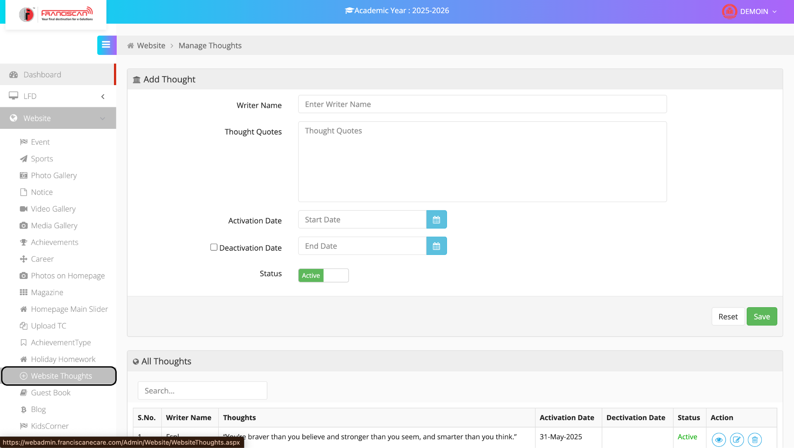

📘 ERP Manual: Website Thoughts

📍 Page Location:
Menu > Website > Website Thoughts

🎯 Purpose:
To manage motivational or inspirational quotes for display on the school website or LFD (Large Format Display).

📝 Steps to Add a Thought
- Writer Name
➤ Enter the name of the person who wrote the quote (e.g., A.P.J. Abdul Kalam).
- Thought Quotes
➤ Enter the full quote or thought to be displayed.
- Activation Date
➤ Select the start date from when the quote will appear.
- Deactivation Date (Optional)
➤ Tick the checkbox and choose the end date if you want to limit the display duration.
- Status
➤ Set to:
  - Active – Quote will be visible.
  - Inactive – Quote will be hidden.
- Buttons
  - Save: Save the quote entry.
  - Reset: Clear the form inputs.

📂 View & Manage Thoughts
The table below the form shows all existing quotes, including:
- Writer Name
- Thought Text
- Activation/Deactivation Dates
- Status
- Actions:
  - 👁 View
  - ✏️ Edit
  - 🔄 Activate/Deactivate
  - 🗑 Delete
2.16 Guest Book
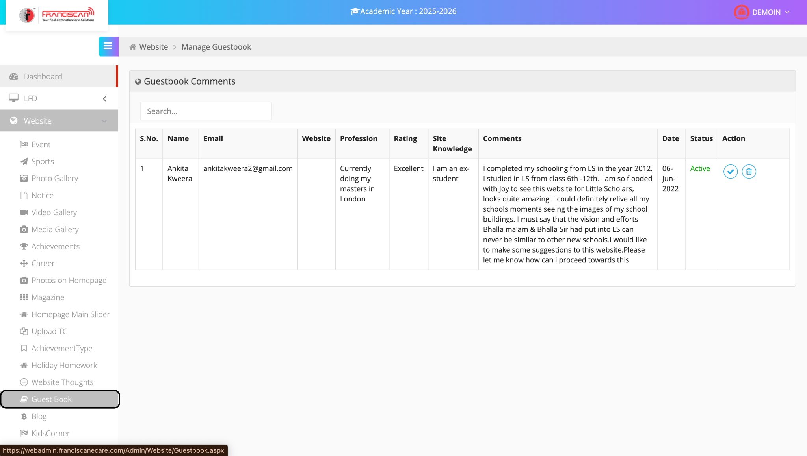

📘 ERP Manual: Guest Book

📍 Page Location:
Menu > Website > Guest Book

🎯 Purpose:
To manage feedback, testimonials, or comments submitted by visitors (students, alumni, parents, etc.) on the school's website.

📂 Guestbook Comments Table
This section displays all submitted guestbook entries with the following columns:
Column | Description
S.No. | Serial number of the entry.
Name | Name of the person who submitted the comment.
Email | Their email ID for contact/reference.
Website | (Optional) Personal/professional website if provided.
Profession | Current professional role (e.g., Student, Teacher, Doctor).
Rating | Visitor’s feedback (e.g., Excellent, Good).
Site Knowledge | How they know about the website (e.g., Ex-student, Parent).
Comments | The actual feedback or message written by the user.
Date | Submission date of the comment.
Status | Indicates whether the comment is Active (visible) or not.
Action | Icons to approve, deactivate, or delete the comment.

✅ Actions
- ✔️ Approve (tick icon): Makes the comment visible on the website.
- ❌ Delete (bin icon): Permanently removes the comment.
- 🔄 Some systems may also include edit or deactivate options.
2.17 Blog
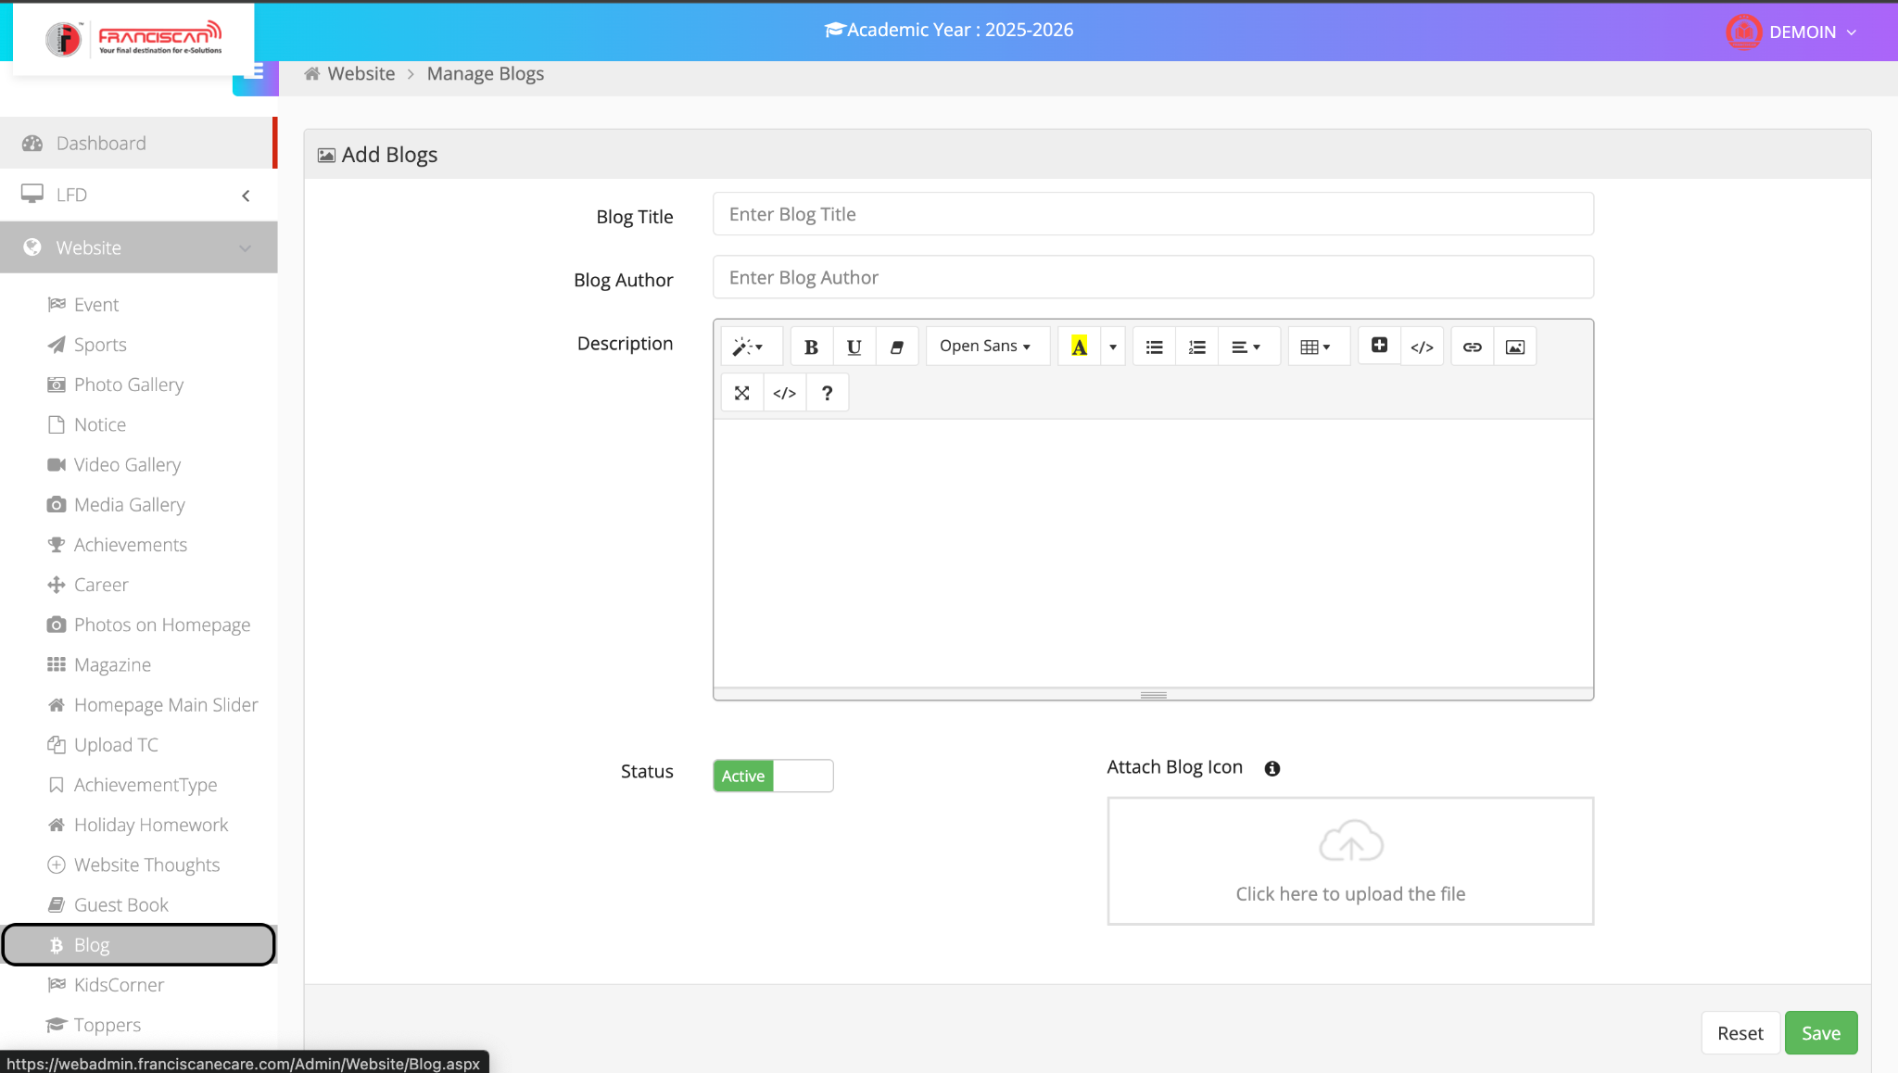

📘 ERP Manual: Manage Blog Page

📍Navigation:
Website → Blog

➕ Add Blog
This section allows the admin to create and publish blog posts on the school website.

🔹 Form Fields:
- Blog Title
  - Enter the title of the blog post (e.g., Annual Science Fair Highlights).
- Blog Author
  - Enter the name of the author (e.g., John Smith or Admin Team).
- Description
  - Write the full blog content here.
  - You can format text using:
    - Bold, Italic, Underline
    - Font type and size
    - Lists, alignment, table, links, and image embedding.
- Attach Blog Icon
  - Upload an image/icon representing the blog.
  - Click “Click here to upload the file” and select an image from your system.
- Status
  - By default, the blog is set to Active.
  - Toggle the switch to deactivate if needed.

✅ Actions
- Save: Submits and publishes the blog to the school website.
- Reset: Clears all entered fields.
2.18 Kids corner 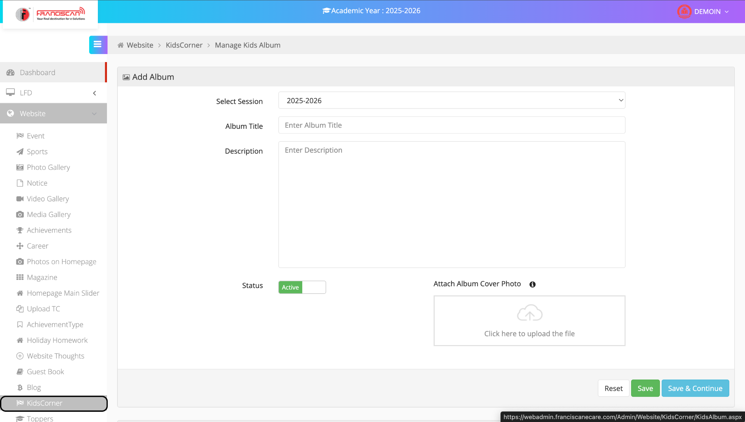

📘 ERP Manual: Manage Kids Album Page

📍Navigation:
Website → KidsCorner → Manage Kids Album

➕ Add Album
This feature allows the admin to create photo albums specifically for KidsCorner to showcase activities, artwork, and events related to children.

🔹 Form Fields:
- Select Session
  - Select the academic session (e.g., 2025-2026).
  - This helps organize albums by academic year.
- Album Title
  - Enter a name for the album (e.g., Nursery Art Competition, Fancy Dress Show).
- Description
  - Provide a brief description of the album’s content.
- Attach Album Cover Photo
  - Upload a cover image for the album.
  - Click “Click here to upload the file” to select an image.
- Status
  - Toggle to Active to make the album visible on the website.

✅ Actions
- Save: Saves the album and returns to the list.
- Save & Continue: Saves the album and keeps the user on the same page to add more content.
- Reset: Clears all fields.
2.19 Toppers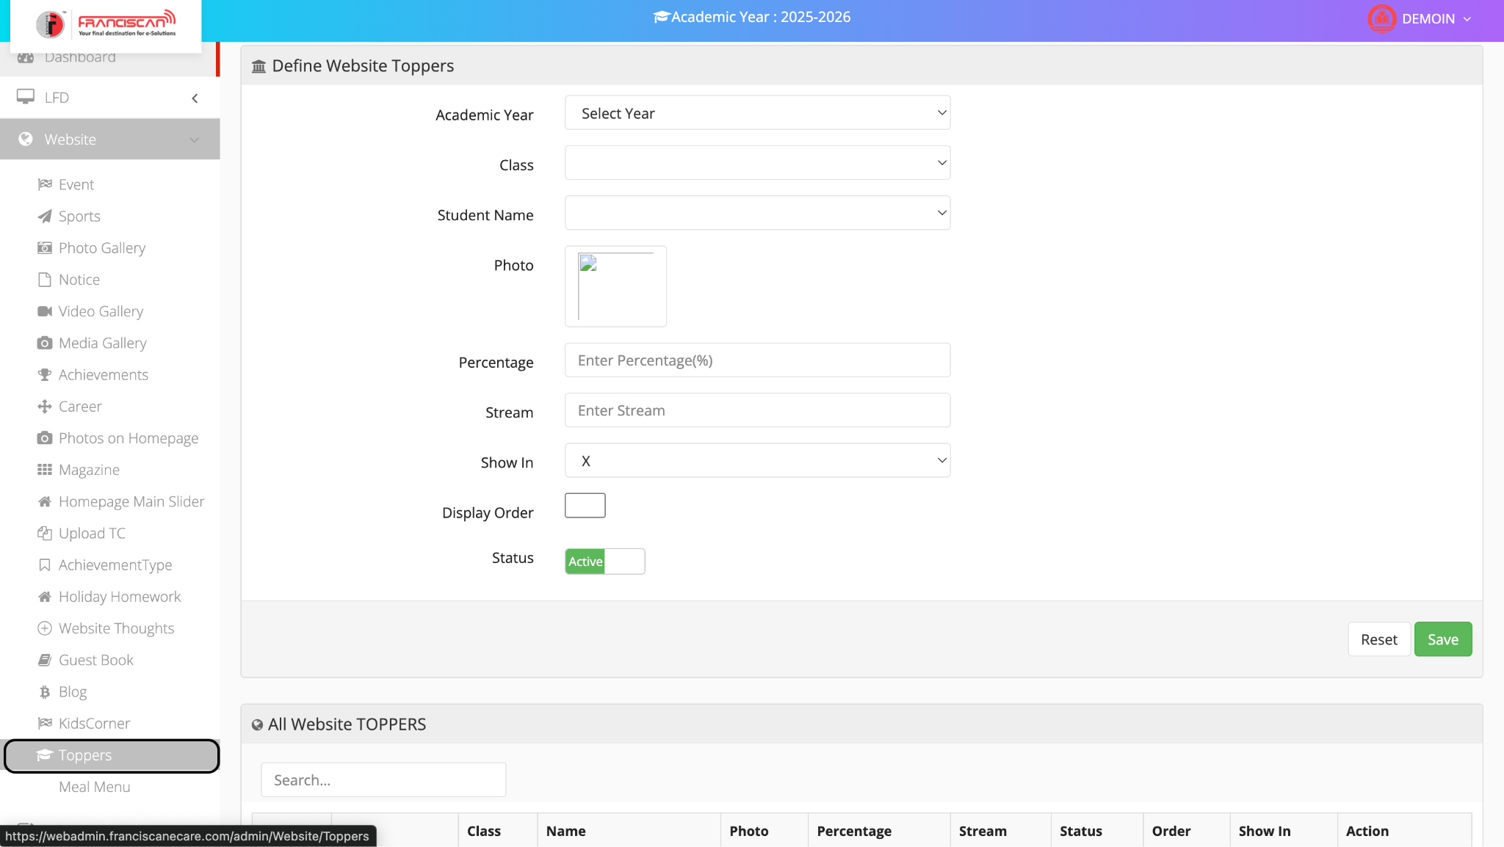

📘 ERP Manual: Define Website Toppers Page

📍Navigation:
Website → Toppers

🏆 Purpose:
This page allows administrators to display student toppers on the school website, including their academic performance and details.

🔹 Form Fields Explanation:
- Academic Year
  - Select the relevant academic session (e.g., 2025-2026).
- Class
  - Choose the class of the student topper (e.g., X, XII).
- Student Name
  - Select the student from the dropdown list.
- Photo
  - Upload the student's photo using the image upload box.
- Percentage
  - Enter the student’s score in percentage (e.g., 96.5).
- Stream
  - Mention the academic stream (e.g., Science, Commerce, Arts).
  - Applicable mainly for senior classes.
- Show In
  - Choose the category the topper is to be shown in (e.g., X, XII).
- Display Order
  - Enter the order in which the topper should be displayed.
  - Lower numbers are shown first.
- Status
  - Toggle Active to show on the website.
  - Toggle off to hide.

✅ Buttons:
- Save: Saves the record and displays it in the list below.
- Reset: Clears all input fields.

📋 Bottom Table: All Website Toppers
- View all added toppers with details like Class, Name, Photo, Percentage, Stream, Status, Display Order, and available actions (Edit/Delete).
2.20 Meal Menu
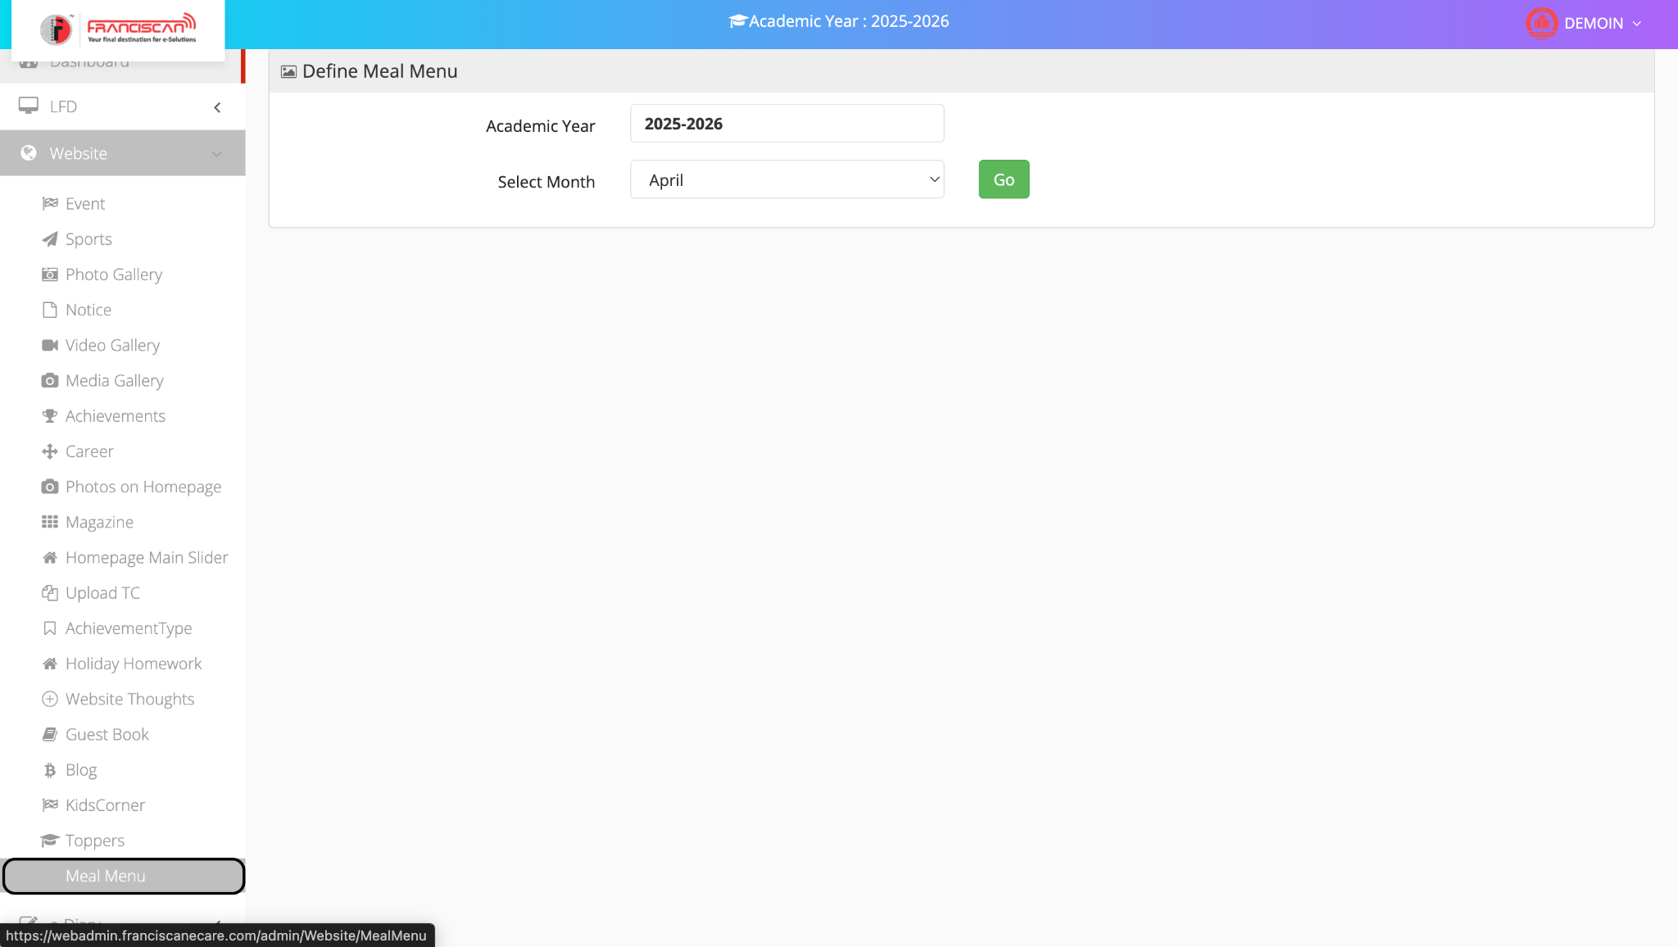

📘 ERP Manual: Define Meal Menu Page

📍Navigation:
Website → Meal Menu

🍽️ Purpose:
This module is used to define and manage the monthly meal plan for students, which is displayed on the school website or portal.

🔹 Form Fields Explanation:
- Academic Year
  - Displays the currently selected academic session (e.g., 2025–2026).
  - This is pre-filled and not editable.
- Select Month
  - Choose the month for which you want to define the meal menu (e.g., April, May, etc.).
- Go Button
  - Click this button to load or define the meal details for the selected month.

📌 Next Steps After Clicking "Go":
After clicking Go, the system will display a day-wise calendar grid (not shown in the current screenshot) where you can:
- Enter meal details (e.g., breakfast, lunch items) for each date.
- Save the meal plan.
- Edit or update previously entered menus.

3.e-Diary
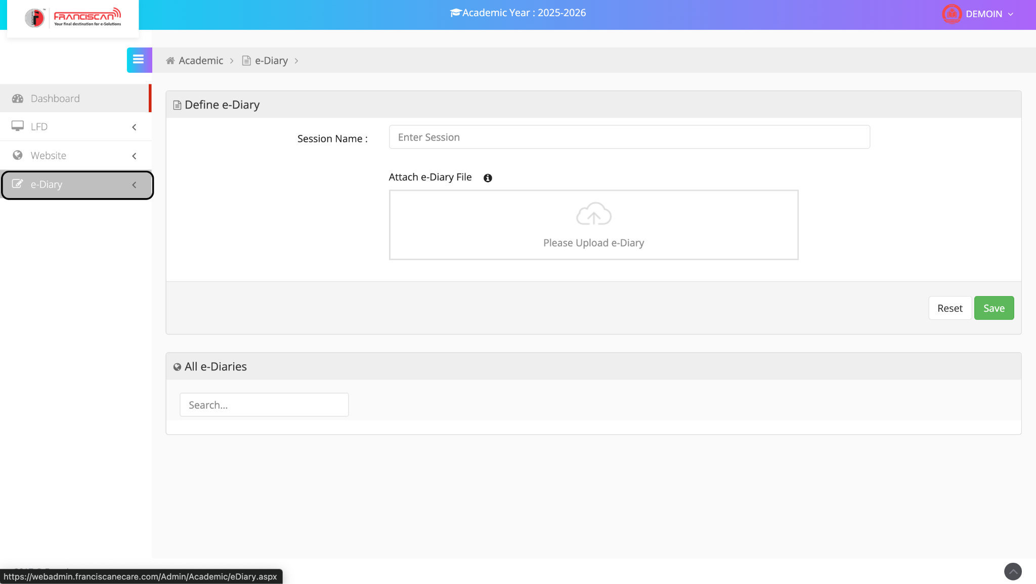

📘 ERP Manual: Define e-Diary Page

📍Navigation:
Academic → e-Diary

📝 Purpose:
This module allows the school to upload and manage e-Diary files (digital student diaries) for a specific session. These files can include rules, schedules, and important academic instructions.

🔹 Form Fields Explanation:
- Session Name
  - Enter the name of the session (e.g., 2025–2026, Term 1, etc.)
  - This helps categorize the e-Diary by academic period.
- Attach e-Diary File
  - Upload the e-Diary document (PDF, Word, etc.).
  - Drag and drop or click to browse and select the file.

✅ Buttons:
- Save: Uploads and saves the e-Diary file to the system.
- Reset: Clears all entered data and resets the form.

📚 All e-Diaries (Below Section):
- Displays a list of all uploaded e-Diaries.
- Allows searching using the search box to find specific entries.

